2022-23- Progression of Skills and Knowledge in DT
EYFS | What? | Framework statements | Key Vocab
3 and 4 year olds | PSED | - Select and use activities and resources, with help when needed. This helps them to achieve a goal they have chosen or one which is suggested to them. | Materials, resources, choose, finished, next
 | Physical Development | - Use large-muscle movements to wave flags and streamers, paint and make marks.  - Choose the right resources to carry out their own plan.  - Use one-handed tools and equipment, for example, making snips in paper with scissors. | Big, move, flags, streamers, paint, paintbrush, marks, colour
 | Understanding the world | - Exploring how things work. | Up, down, on, off, why, how
 | Expressive art and design | - Make imaginative and complex ‘small worlds’ with blocks and construction kits, such as a city with different buildings and a park.  - Explore different materials freely, in order to develop their ideas about how to use them and what to make.  - Develop their own ideas and then decide which materials to use to express them.  - Create closed shapes with continuous lines, and begin to use these shapes to represent objects. | Building, real world words, stack, make, looks like, shape, round, square, line, circle,
Reception | Physical Development | - Progress towards a more fluent style of moving, with developing control and grace.  - Develop their small motor skills so that they can use a range of tools competently, safely and confidently.  - Use their core muscle strength to achieve a good posture  - when sitting at a table or sitting on the floor. | Hold, control, safely, firm, sit up, back straight, legs crossed, feet on floor, bottom on seat
 | Expressive arts and Design | - Explore, use and refine a variety of artistic effects to express their ideas and feelings.  - Return to and build on their previous learning, refining ideas and developing their ability to represent them.  - Create collaboratively, sharing ideas, resources and skills. | Like, dislike, because
ELG | Physical Development- Fine motor Skills | - Use a range of small tools, including scissors, paintbrushes and cutlery. | Scissors, cut, half, pieces, knife, fork, spoon
 | Expressive art and design- creating with materials | - Safely use and explore a variety of materials, tools and techniques, experimenting with colour, design, texture, form and function.  - Share their creations, explaining the process they have used. | Tool, material, technique, colour, design, texture, form, function

Our Topic Based Curriculum 2022-23- DT
Year 1 | What? | Picture | Key Vocab | National Curriculum/ skills
Terrific Toys   | Pop up toy | 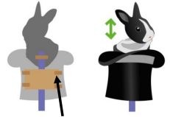 | slider, lever, pivot, slot, bridge/guide, mechanism, card, masking tape, paper fastener, join, pull, push, up, down, straight, curve, forwards, backwards | - Explore and use mechanisms, such as levers, sliders, in their products.  - design products that have a purpose and are aimed at an intended user;  - plan and test ideas using templates and mock-ups;  - begin to select from a range of hand tools and equipment evaluate their products and ideas against their simple design criteria;  - start to understand that the iterative process sometimes involves repeating different stages of the process.
Penguins and Polar Bears   | Glove puppet |  | attach, decoration, jottings, textiles, running stitch, seam allowance, applique, score | - Select from and use a range of tools and equipment to perform practical tasks such as cutting, shaping, joining and finishing  - explain how their products will look and work through talking and simple annotated drawings;  - use a range of materials and components  - with help, measure and mark out  - demonstrate how to cut, shape and join fabric to make a simple product;  - manipulate fabrics in simple ways to create the desired effect;  - use a basic running stich;
Victorian Venture   | Cooking – Fruit salad | 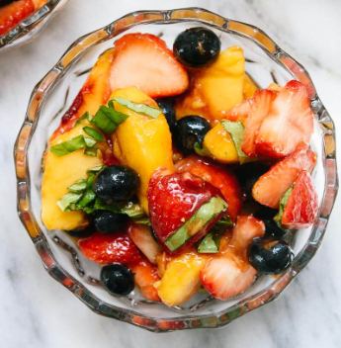 | How food came over here? Wealth  fruit names, names of equipment and utensils sensory vocabulary (soft, juicy, crunchy, sweet, sticky, smooth, sharp, crisp, sour, hard) flesh, skin, seed, pip, core, slicing, peeling, cutting, squeezing, healthy diet, ingredients | - Understand where food comes from  - Use the basic principles of a healthy and varied diet to prepare dishes  - name and sort foods into the five groups in the Eatwell Guide;  - understand that everyone should eat at least five portions of fruit and vegetables every day and start to explain why;  - with support, follow a simple plan or recipe;

Our Topic Based Curriculum 2022-23- DT
Year 2 | What? | Picture | Key Vocab | National Curriculum/ skills
  What  makes  Britain  Great? | Cooking- Soup | 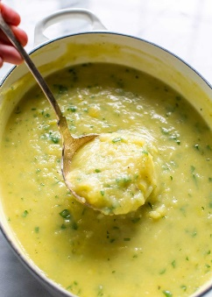 | British seasonality, where food comes from? Harvest festival link.  fruit names, names of equipment and utensils sensory vocabulary, flesh, skin, seed, pip, core, slicing, peeling, cutting, squeezing, healthy diet, ingredients | - Understand where food comes from  - Use the basic principles of a healthy and varied diet to prepare dishes  - understand that all food comes from plants or animals;  - understand that food has to be farmed, grown elsewhere (e.g. home) or caught;  - learn to use hand tools and kitchen equipment safely and appropriately and learn to follow hygiene procedures;  - cut, peel and grate ingredients, including measuring and weighing ingredients using measuring cups
Super Cities   | Transport/vehicles to move around different cities | 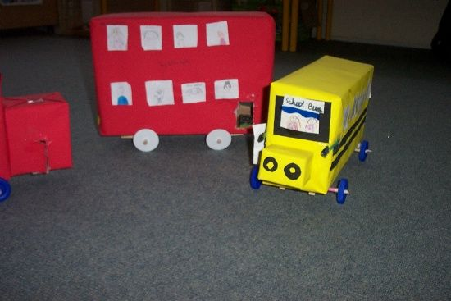 | vehicle, wheel, axle, axle holder, chassis, body, cab assembling, cutting, joining, shaping, finishing, fixed, free, moving, mechanism names of tools, equipment and materials used | - Explore and use mechanisms, such as levers, sliders, wheels and axles, in their products.  - use their knowledge of existing products and their own experience to help generate their ideas;  - understand and follow simple design criteria;  - select from a range of materials, textiles and components according to their characteristics;  - talk about their design ideas and what they are making;  - as they work, start to identify strengths and possible changes they might make to refine their existing design;
Magnificently Medieval  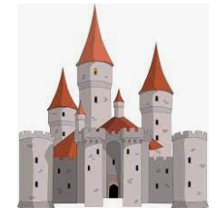 | Drawbridge – castles | 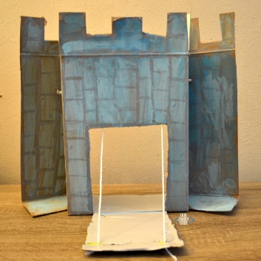 | cut, fold, join, fix structure, wall, tower, framework, weak, strong, base, top, underneath, side, edge, surface, thinner, thicker, corner, point, straight, curved, metal, wood, plastic circle, triangle, square, rectangle, cuboid, cube, cylinder | - Build structures, exploring how they can be made stronger, stiffer and more stable  - design models using simple computing software;  - cut, shape and score materials with some accuracy;  - assemble, join and combine materials or components  - begin to use simple finishing techniques to improve the appearance of their product.  - explain positives and things to improve for existing products;  - explore what materials products are made from;

Our Topic Based Curriculum 2022-23- DT
Year 3 | What? | Picture | Key Vocab | National Curriculum/ skills
Savage Stone Age  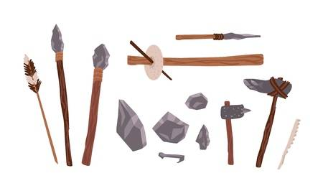 | Stone age tools | 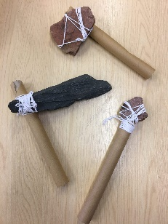 | Suitability, aesthetic, procedures, accuracy, cutting, shaping, joining, finishing, accuracy, assemble, combine, components, equipment, techniques, measure, mark out, drilling, gluing, filing, sanding, | - Select from and use a wider range of tools and equipment to perform practical tasks, such as cutting, shaping, joining and finishing, accurately  - Select from and use a wider range of materials and components, including construction materials, according to their functional properties and aesthetic qualities  - explain how particular parts of their products work  - use their knowledge of a broad range of existing products to help generate their ideas;  - with growing confidence, carefully select from a range of tools and equipment, explaining their choices;
Rotten Romans  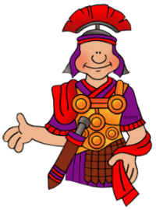 | Trebuchet | 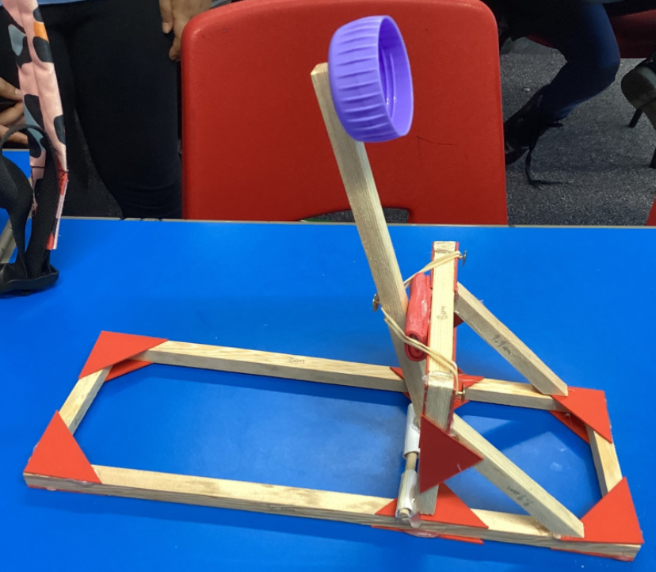 | Suitability, aesthetic, procedures, accuracy, cutting, shaping, joining, finishing, accuracy, assemble, combine, components, equipment, techniques, measure, mark out, drilling, gluing, filing, sanding, | - Select from and use a wider range of tools and equipment to perform practical tasks, such as cutting, shaping, joining and finishing, accurately  - Select from and use a wider range of materials and components, including construction materials, according to their functional properties and aesthetic qualities  - identify the design features of their products that will appeal to intended customers;  - design innovative and appealing products that have a clear purpose and are aimed at a specific user;  - select from a range of materials and components according to their functional properties and aesthetic qualities;  - cut, shape and score materials with some degree of accuracy;  - evaluate their product against their original design criteria
Exploring Europe   | Cooking- Tapas | 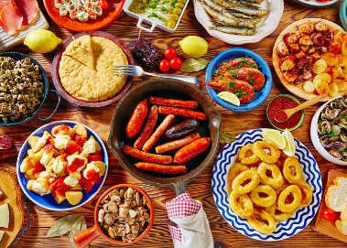 | name of products, equipment, utensils, techniques and ingredients texture, taste, sweet, sour, hot, spicy, appearance, smell, preference, greasy, moist, cook, fresh, savoury, hygienic, edible, grown, reared, caught, frozen, tinned, processed, seasonal, harvested healthy/varied diet | - Prepare and cook a variety of predominantly savoury dishes using a range of cooking techniques  - Understand seasonality and know where and how a variety of ingredients are grown, reared, caught and processed.  - learn to use a range of tools and equipment safely, appropriately and accurately and learn to follow hygiene procedures;  - start to know when, where and how food is grown  - start to independently follow a recipe

Our Topic Based Curriculum 2022-23- DT
Year 4 | What? | Picture | Key Vocab | National Curriculum/ skills
Vicious Vikings  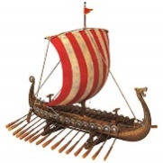 | Viking longship  Cooking- Stew | 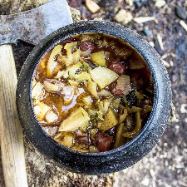  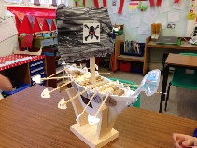 | levers with moving oars, Suitability, aesthetic, procedures, accuracy, cutting, shaping, joining, finishing, accuracy, assemble, combine, components, equipment, techniques, measure, mark out, drilling, gluing, filing, sanding,  name of products, equipment, utensils, techniques and ingredients texture, taste, sweet, sour, hot, spicy, appearance, smell, preference, greasy, moist, cook, fresh, savoury, hygienic, edible, grown, reared, caught, frozen, tinned, processed, seasonal, harvested healthy/varied diet | - Understand and use mechanical systems in their products, levers and linkages.  - Understand seasonality and know where and how a variety of ingredients are grown, reared, caught and processed.  - Prepare and cook a variety of predominantly savoury dishes using a range of cooking techniques  - test ideas out through using prototypes;  - place the main stages of making in a systematic order;  - use a wider range of materials and components  - assemble, join and combine material and components with some degree of accuracy  - consider their design criteria as they make progress and are willing to alter their plans, sometimes considering the views of others if this helps them to improve their product  - understand how to prepare and cook a variety of predominantly savoury dishes safely and hygienically  - explain that a healthy diet is made up of a variety and balance of different food and drink,  - prepare ingredients using appropriate cooking utensils;  - measure and weigh ingredients to the nearest gram and millilitre;
Awesome Asia   | Cooking- Samosa | 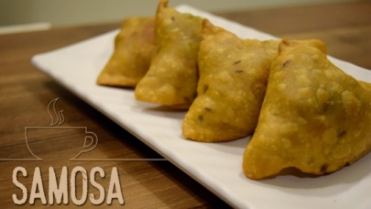 | name of products, equipment, utensils, techniques and ingredients texture, taste, sweet, sour, hot, spicy, appearance, smell, preference, greasy, moist, cook, fresh, savoury, hygienic, edible, grown, reared, caught, frozen, tinned, processed, seasonal, harvested healthy/varied diet | - Prepare and cook a variety of predominantly savoury dishes using a range of cooking techniques  - Understand and apply the principles of a healthy and varied diet  - Understand seasonality and know where and how a variety of ingredients are grown.  - explore what materials/ingredients products are made from and suggest reasons for this;  - with support, use a heat source to cook ingredients showing awareness of the need to control the temperature of the hob and/or oven;  - use a range of techniques such as mashing, whisking, crushing, grating, cutting, kneading and baking;
Raging Rivers   | Bridges | 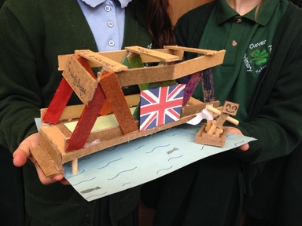 | corruflute, card  Frame structure, stiffen, strengthen, reinforce, triangulation, stability, shape, join, temporary, permanent. Suitability, aesthetic, procedures, accuracy, cutting, shaping, joining, finishing, accuracy, assemble, combine, components, equipment, techniques, measure, mark out, drilling, gluing, filing, sanding, | - Select from and use a wider range of tools and equipment to perform practical tasks, such as cutting, shaping, joining and finishing, accurately.  - Select from and use a wider range of materials and components, including construction materials, according to their functional properties and aesthetic qualities.  - Apply their understanding of how to strengthen, stiffen and reinforce more complex structures.  - use their knowledge of a broad range of existing products to help generate their ideas;  - use annotated sketches and cross-sectional drawings to develop and communicate their ideas;  - when designing, explore different initial ideas before coming up with a final design;  - when planning, start to explain their choice of materials and components including function and aesthetics;  - explore and evaluate existing products, explaining the purpose of the product and whether it is designed well to meet the intended purpose;
Rotten Romans  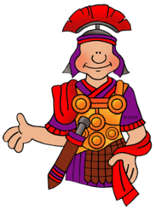 | Trebuchet |  | Frame structure, stiffen, strengthen, reinforce, triangulation, stability, shape, join, temporary, permanent. Suitability, aesthetic, procedures, accuracy, cutting, shaping, joining, finishing, accuracy, assemble, combine, components, equipment, techniques, measure, mark out, drilling, gluing, filing, sanding, | - Select from and use a wider range of tools and equipment to perform practical tasks, such as cutting, shaping, joining and finishing, accurately.  - Select from and use a wider range of materials and components, including construction materials, according to their functional properties and aesthetic qualities.  - Apply their understanding of how to strengthen, stiffen and reinforce more complex structures.  - use computer-aided design to develop and communicate their ideas (see note on p. 1); develop and follow simple design criteria;  - with growing independence, measure and mark out to the nearest cm and millimetre;  - identify the design features of their products that will appeal to intended customers;  - design innovative and appealing products that have a clear purpose and are aimed at a specific user;  - select from a range of materials and components according to their functional properties and aesthetic qualities;  - cut, shape and score materials with some degree of accuracy;  - evaluate their product against their original design criteria

Our Topic Based Curriculum 2022-23- DT
Year 5 | What? | Picture | Key Vocab | National Curriculum/ skills
Vicious Vikings | Viking longship  Cooking- Stew |  | levers with moving oars, Suitability, aesthetic, procedures, accuracy, cutting, shaping, joining, finishing, accuracy, assemble, combine, components, equipment, techniques, measure, mark out, drilling, gluing, filing, sanding,  ingredients, spice, herbs fat, sugar, carbohydrate, protein, vitamins, nutrients, nutrition, healthy, varied, gluten, dairy, savoury, source, seasonality, utensils, combine, stir, pour, mix, rubbing in, whisk, beat | - Understand and use mechanical systems in their products, levers and linkages.  - Understand seasonality and know where and how a variety of ingredients are grown, reared, caught and processed.  - Prepare and cook a variety of predominantly savoury dishes using a range of cooking techniques  - use research to inform and develop detailed design criteria to inform the design of innovative, functional and appealing products that are fit for purpose and aimed at a target market;  - generate a range of design ideas and clearly communicate final designs;  - learn to use a range of tools and equipment safely and appropriately and learn to follow hygiene procedures;  - assemble, join and combine materials and components with accuracy;  - demonstrate how to prepare and cook a variety of predominantly savoury dishes safely and hygienically including, where appropriate, the use of a heat source
Does money make the world go round?   | Cooking- Meal using fair trade ingredients  Bag for life | 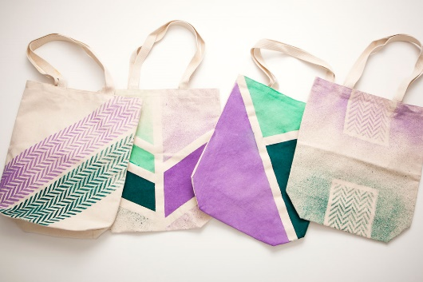 | strong enough handle. Sewing, seam, seam allowance, wadding, reinforce, right side, wrong side, hem, template, pattern pieces, name of textiles and fastenings used, pins, needles, thread, pinking shears, fastenings,  ingredients, yeast, dough, bran, flour, wholemeal, unleavened, baking soda, spice, herbs fat, sugar, carbohydrate, protein, vitamins, nutrients, nutrition, healthy, varied, gluten, dairy, allergy, intolerance, savoury, source, seasonality utensils, combine, fold, knead, stir, pour, mix, rubbing in, whisk, beat, roll out, shape, sprinkle, crumble  Frame structure, stiffen, strengthen, reinforce, triangulation, stability, shape, join, temporary, permanent, Suitability, aesthetic, procedures, accuracy, cutting, shaping, joining, finishing, accuracy, assemble, combine, components, equipment, techniques, measure, mark out, drilling, gluing, filing, sanding, | - Prepare and cook a variety of predominantly savoury dishes using a range of cooking techniques.  - Understand and apply the principles of a healthy and varied diet.  - Understand seasonality and know where and how a variety of ingredients are grown.  - Select from and use a wider range of tools and equipment to perform practical tasks, such as cutting, shaping, joining and finishing, accurately.  - Select from and use a wider range of materials and components, including textiles, according to their functional properties and aesthetic qualities.  - Apply their understanding of how to strengthen, stiffen and reinforce more complex structures.  - use their knowledge of a broad range of existing products to help generate their ideas;  - consider the availability and costings of resources when planning out designs;  - demonstrate how to measure, make a seam allowance, tape, pin, cut, shape and join fabric with precision to make a more complex product;  - join textiles using a greater variety of stitches, such as backstitch, whip stitch, blanket stitch;  - complete detailed competitor analysis of other products on the market;  - know, explain and give examples of food that is grown, reared and caught in the UK, Europe and the wider world;  - adapt and refine recipes by adding or substituting one or more ingredients to change the appearance, taste, texture and aroma;

Our Topic Based Curriculum 2022-23- DT
Year 6 | What? | Picture | Key Vocab | National Curriculum/ skills
Mighty Mayans   | Cooking- Chilli tacos  Chilli tuffles  Boxes for chilli truffles  (Big Write) | 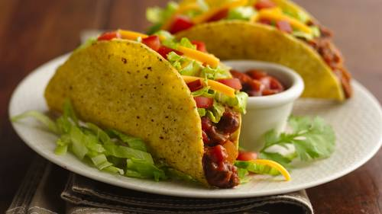  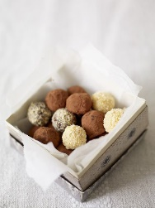 | ingredients, yeast, dough, bran, flour, wholemeal, unleavened, baking soda, spice, herbs fat, sugar, carbohydrate, protein, vitamins, nutrients, nutrition, healthy, varied, gluten, dairy, allergy, intolerance, savoury, source, seasonality utensils, combine, fold, knead, stir, pour, mix, rubbing in, whisk, beat, roll out, shape, sprinkle, crumble.  Frame structure, stiffen, strengthen, reinforce, triangulation, stability, shape, join, temporary, permanent | - Prepare and cook a variety of predominantly savoury dishes using a range of cooking techniques.  - Apply their understanding of how to strengthen, stiffen and reinforce more complex structures.  - design products that have a clear purpose and indicate the design features of their products that will appeal to the intended user;  - independently plan by suggesting what to do next;  - create step-by-step plans as a guide to making  - cut a range of materials with precision and accuracy;  - use a full range of materials and components, including construction materials and kits, textiles, and mechanical components;  - critically evaluate the quality of design, manufacture and fitness for purpose of products as they design and make;  - understand that food is processed into ingredients that can be eaten or used in cooking;  - independently follow a recipe.
Woeful Wars   | Cooking- WW1 meal  Cannons | 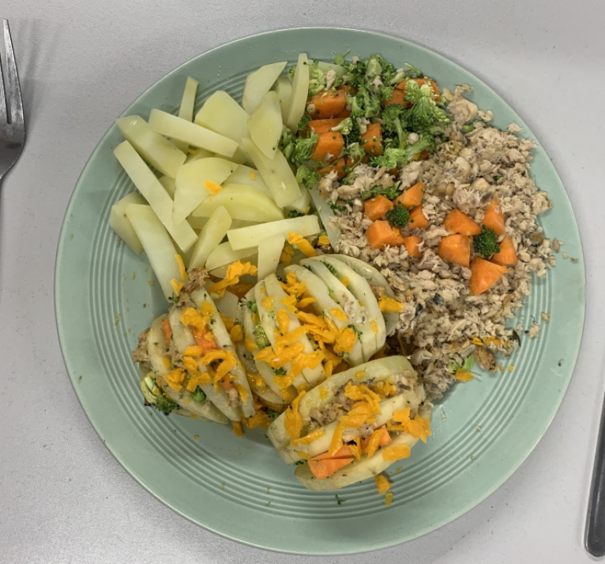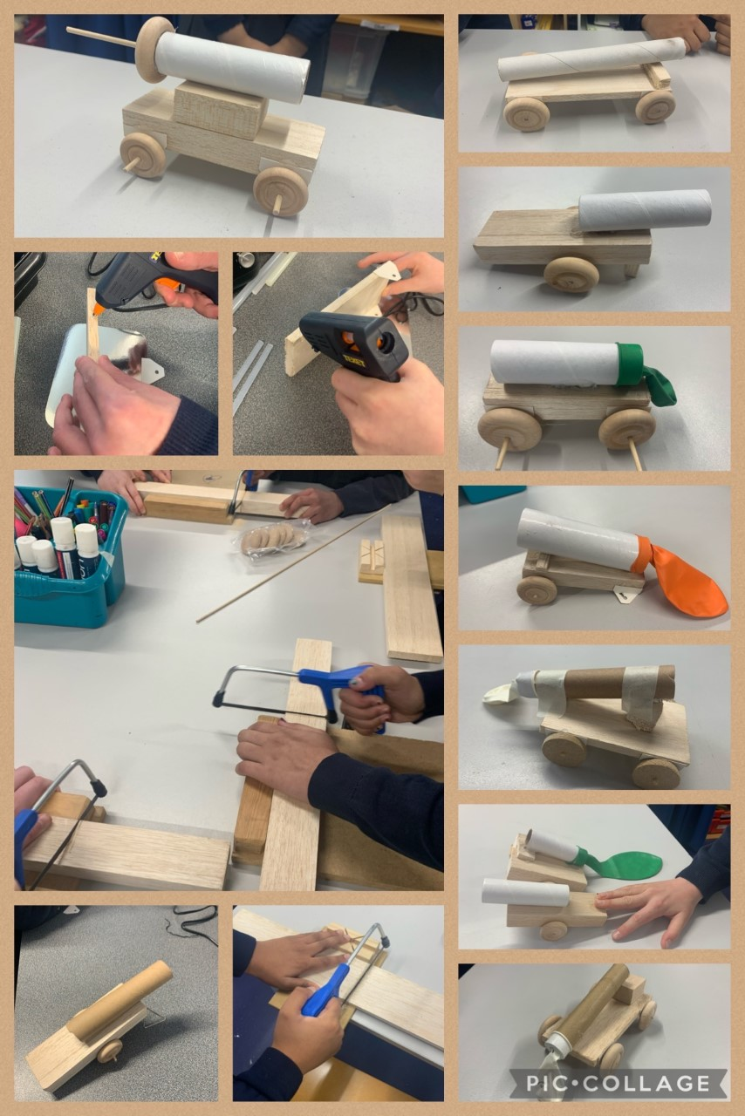 | Seasonal, Rationing, ingredients, yeast, dough, bran, flour, wholemeal, unleavened, baking soda, spice, herbs fat, sugar, carbohydrate, protein, vitamins, nutrients, nutrition, healthy, varied, gluten, dairy, allergy, intolerance, savoury, source, seasonality utensils, combine, fold, knead, stir, pour, mix, rubbing in, whisk, beat, roll out, shape, sprinkle, crumble.  Suitability, aesthetic, procedures, accuracy, cutting, shaping, joining, finishing, accuracy, assemble, combine, components, equipment, techniques, measure, mark out, drilling, gluing, filing, sanding, | - Understand and apply the principles of a healthy and varied diet.  - Understand seasonality and know where and how a variety of ingredients are grown.  - Select from and use a wider range of tools and equipment to perform practical tasks, such as cutting, shaping, joining and finishing, accurately.  - Select from and use a wider range of materials and components, including construction materials, according to their functional properties and aesthetic qualities.  - explain how particular parts of their products work;  - with growing confidence, select from a wide range of tools and equipment, explaining their choices;  - independently take exact measurements and mark out, to within 1 millimetre;  - refine the finish using techniques to improve the appearance of their product, such as sanding or a more precise scissor cut after roughly cutting out a shape.  - understand about seasonality, how this may affect the food availability and plan recipes according to seasonality;  - alter methods, cooking times and/or temperatures;  - measure accurately and calculate ratios of ingredients to scale up or down from a recipe;
One Leicester, One World   | The world | 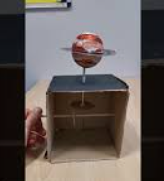 | Cams, linkages, mechanical cams, pulleys, gears, movement, linkages, forces | - Understand and use mechanical systems in their products, such as gears, pulleys, cams, levers and linkages.  - use annotated sketches, cross-sectional drawings and exploded diagrams (possibly including computer-aided design) to develop and communicate their ideas;  - select from a range of materials and components according to their functional properties and aesthetic qualities;  - shape and score materials with precision and accuracy  - evaluate their ideas and products against the original design criteria, making changes as needed.

