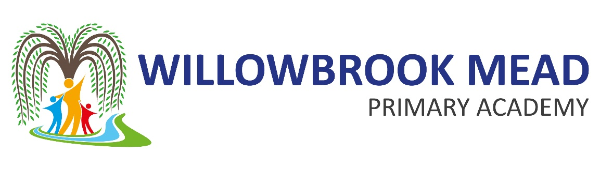

Early Reading and Phonics

2023-2024

‘Reading is fundamental to education. Proficiency in reading, writing and spoken language is vital for pupils’ success. Through these, they develop communication skills for education and for working with others: in school, in training and at work.’ DFE 2023

Contents

Contents 2
Overview 3
Early Reading 3
Books 3
Reading at home 3
Love of reading 4
Development of Language 4
Reading corners 4
Reading Incentive 5
Phonics 6
Phonics scheme 6
Phonics interventions 6
Parental engagement 6
Monitoring and assessment 7
Reception 7
Year 2 7
New to English 7

Overview
At Willowbrook Mead, we are proud to offer the pupils a text rich learning environment where imagination and creativity can be fuelled. Through our rigorous phonics curriculum, we ensure pupils develop the skills and knowledge they need to develop as confident readers who have a love of books. Through reading in particular, pupils have a chance to develop culturally, emotionally, intellectually, socially and spiritually.
Early reading and phonics are included on our school improvement plan and is considered a priority in teaching and learning across the school. We know that many of our children start in our nursery and reception years with low vocabulary and comprehension. We also have seen the impact of Covid on children in recent years, which has affected children’s reading ability and understanding. Our focus is to ensure that all children are given the best start in their education through the effective teaching of systematic phonics and through a vocabulary-rich curriculum.

Early Reading

Books
We have a wide range of books across our infant and junior libraries. Children are encouraged to visit the school library with their teacher and access the reading corners in their classroom. Teachers also have a selection of their own favourite books that they share with the children daily.
We also have our RWI Ditty books and story books, and these are used during phonics sessions in school and sent home with the children to practise. Teachers will match the children with the correct level book based on their phonics assessment.
The local book bus library attends our school once a week and parents can take their children to choose a book and take it home to read. This is encouraged throughout KS1 with a visit to the book bus and children showing them the different books available for them.

Reading at home
As a school, we understand the importance of reading at home, and the positive impact of children being read to, in terms of their language and vocabulary. We share details with parents of the importance of reading at home and provide them with ideas of how this can be an enjoyable experience and a chance to spend time with their children and talk about stories.
The children all have a reading record that they keep in their bookbag. This allows for teachers and parents to comment on the children’s reading and progress. Teachers can identify words to practise at home and give helpful advice to parents.
All children will have a RWI book that matches their progress with the sounds that they have learnt in school. Teachers are to continually monitor the book match and ensure children have the correct books to take home.
Children also to take home a book of their choice (library book) to encourage love of reading.
Children in reception and year 1 also take a phonics book home that includes sounds where they can practise their sound recognition and practise writing the sounds.
School subscription to Oxford Owl allows parents to access books at home on their devices through Reading buddy. Accelerated reader is used for years 2-6.

Love of reading
In EYFS and KS1, we ensure that children are exposed to two stories every day. This can be part of maths lessons or linked to topic with non-fiction books. Our curriculum is rich in texts and stories. We understand that stories are linked to developing a rich vocabulary in children
At Willowbrook Mead, we want to create a love of reading for all children. There are many ways that we aim to do this:
- Our corridor display is based on teacher’s favourite authors
- Staff from around the school (principal, premises officer, family support worker) reading stories to the children
- Children can read to Dottie, our school dog
- Reading calendar of events throughout the year which include bedtime stories, staff dress up, cinema nights, book quiz
- ‘Drop everything and read’ days throughout the year where children are allowed to sit and read for pleasure
- ‘Reading buddies’ where the children in KS2 visit the KS1 children and read to them
- Visits to the book bus
- Annual book fair- where children can attend before or after school to purchase books

Development of Language
Children start at Willowbrook with varied language and vocabulary. As the DFE 2023 states ‘The number of words a child has heard and can speak by the age of three is a predictor of later language development, so these early vocabulary gains are critically important’. Therefore, we ensure that our environments are language-rich and that teachers and staff model different vocabulary daily.
In our nursery, we have the Early Ralk Boost intervention which is a targeted intervention aimed at 3-4 year old children who need help with talking and understanding words, helping to boost their language skills to narrow the gap between them and their peers. The programme aims to accelerate children’s progress in language and communication by an average of 6 months, after a nine-week intervention.
We also work closely with the Oracy lead to ensure that teachers are incorporating activities that encourage children to use and develop their language.

Reading corners
All classes have a reading corner accessible to the children. Teachers ensure that there is a range of books for children to choose and these are regularly updated depending on children’s interests and discussions.

Reading Incentive
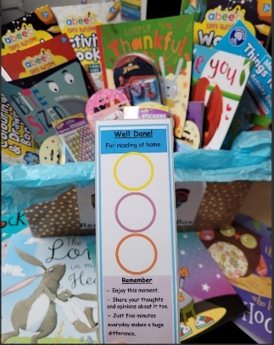
To ensure that all children are encouraged to read at home, we have a reading incentive where children can win a book each half term. The children in EYFS and year 1 have a bookmark. Every time that they read at home, they receive a sticker on their bookmark. Once they have collected three stickers, they get a raffle ticket put into a prize drawer to win a book.

Phonics

Phonics scheme
At Willowbrook Mead we follow the Read Write Inc phonics scheme which is recognised by the DfE as an effective phonics programme.
Our school phonics overview gives more details in to the sounds that children will be learning and the progress that they will make (this is included in a separate document).
All teaching staff are observed in their phonics teaching to ensure consistency.
Recording of phonics work will be in books/ white boards.
Non negotiables in classrooms:
- Phonics freize
- sound mats
- sight word display (red words)
- RWI flashcards for teaching phonics
- Reading books linked to phonics ability

Phonics interventions
We closely monitor our phonics data to ensure that children are reaching their full potential and are all on track for their end of year expectation.
In reception, phonics is taught as whole class for the set 1 sounds. Any child that is falling behind will be given a short 1:1 Intervention with the teacher during the afternoon. The children are then put into ability groups to learn set 2 and 3 sounds depending on their recognition of sounds and blending skills.
Teachers complete the RWI assessment every half term to monitor the children’s progression. This also helps to group the children according to their reading ability.

Parental engagement
We look for opportunities to engage our parents in their child’s learning. Our phonics videos, and information for parents are shared on our website. We also hold parent workshops where we demonstrate a phonics session and explain to parents’ what phonics is for and how they can support their child’s learning at home.
We also invite parents and children to events such as ‘bedtime stories’ where they can engage in stories as a family and read together.

Monitoring and assessment
The early reading and phonics lead will observe teaching off phonics across KS1 weekly through drop ins and learning walks. SLT will also closely monitor book match across the school to ensure that children are able to read independently at home.

Reception
Children complete the statutory Reception Baseline Assessment and teachers also complete their own observations to assess ability. Children complete their set 1 sounds and teachers are consistently assessing for any children that appear to be falling behind and they receive ‘catch up’ sessions’. The children then are assessed using the RWI assessments from Autumn 2. After Christmas they are put into ability groups across the year group and with year 1 if needed.
SEND children are also monitored to ensure that they are exposed to the sane learning and their needs are met through intervention/support if needed.
Year 1-6
Year 1 children and the bottom 20% readers from year 2-6 complete an entry assessment to determine which phonics group they are in. They then complete regular RWI assessments every half term to monitor progress.

New to English
Those children that are new to Willowbrook and new to English will be assessed in their phonics ability within 2 weeks of joining the school. Teachers will work closely with the phonics lead to ensure that children are in an appropriate phonics group/ intervention.

