 | Year 1 | Year 2  History Progression of Skills and Knowledge 2022-23 | Year 3 | Year 4 | Year 5 | Year 6
Topic | Terrific Toys   | Movers & Shakers  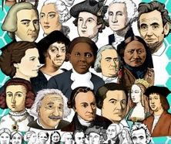 | 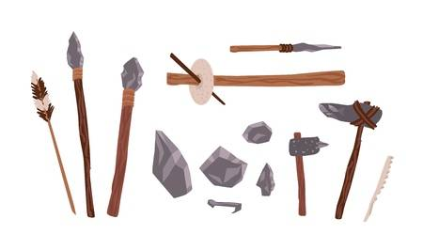  Savage Stone Age | Vicious Vikings  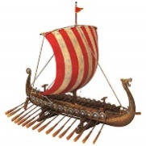 | Groovy Greeks  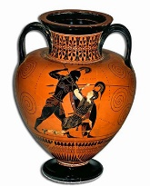 | Mighty Mayans  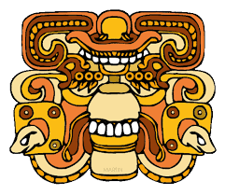
National Curriculum Objectives | *Changes within living memory. Where appropriate, these should be used to reveal aspects of change in national life.  *Identify similarities and differences between ways of life in different periods. | *Changes within living memory. Where appropriate, these should be used to reveal aspects of change in national life.  *Events beyond living memory that are significant nationally and globally (e.g. the Great Fire of London, the first aeroplane flight or events commemorate through festivals or anniversaries).  *The lives of significant individuals in the past who have contributed to national and international achievements. Some should be used to compare aspects of life in different periods (e.g. Elizabeth I and Queen Victoria, Christopher Columbus and Neil Armstrong, William Caxton and Tim Bernes-Lee, Pieter Bruegel the Elder and LS Lowry, Rosa Parks and Emily Davison, Mary Seacole and/or Florence Nightingale and Edith Cavell). | *Changes in Britain from the Stone Age to the Iron Age. This could include:  ** Late Neolithic hunter-gatherers and early farmers, e.g. Skara Brae.  ** Bronze Age religion, technology and travel, e.g. Stonehenge.  ** Iron Age hill forts: tribal kingdoms, farming, art and culture. | *Britain’s settlement by Anglo-Saxons and Scots. This could include:  ** Roman withdrawal from Britain in c. AD 410 and the fall of the western Roman Empire.  ** Scots invasions from Ireland to north Britain (now Scotland).  ** Anglo-Saxon invasions, settlements, and kingdoms: place names and village life.  ** Anglo-Saxon art and culture.  ** Christian conversion – Canterbury, Iona and Lindisfarne.  A Viking and Anglo-Saxon struggle for the Kingdom of England to the time of Edward the Confessor. This could include:  ** Viking raids and invasion  ** Resistance by Alfred the Great and Athelstan, first king of England.  ** Further Biking invasions and Danegeld.  ** Anglo-Saxon laws and justice.  ** Edward the Confessor and his death in 1066. | *Ancient Greece – a study of Greek life and achievements and their influence on the western world. | *A non-European society that provides contrasts with British history – one study chosen from: early Islamic civilization, including a study of Baghdad c. AD 900; Mayan Civilization c. AD 900; Benin (West Africa) c. AD 900-1300.
Key Facts to be taught  Key concept throughout: Change | *How long toys have existed.  *How toys have changed over time and how this has affected our play and free time.  *What toys children played with in the Victorian era. | *Recognise why people did things and why events happened.  *Identify differences between ways of life at different times.  *Understand how people have influenced our understanding of key events.  *Who Malala Yousefzai is  *Who Rosa Parks was  *Who Mary Seacole was | *Natural resources are used differently depending on the land and the settlement.  *Stone age survival.  *Stone henges and Iron age hill forts.  *Changes over time from the Stone Age to now, including settlement, ways of using the lands, food, constructions, transport and others.  *Our lifestyles have considerably changed due to the introduction of different innovations and technology in our life. | *Know why the Vikings came to Britain.  *Understand what made the Vikings successful invaders.  *Know how the Vikings changed and influenced life in Britain.  *Understand how the Viking rule was brought to an end.  *Know why 1066 was such an important year for the Vikings. | *What democracy is and how the Greeks founded it.  *Who the ancient Greeks were and what we have learnt from them?  *The ancient Olympics.  *Ancient Greeks gods and goddesses  *Ancient Greek myths and legends.  *What do we use now because of them? | *Who the Mayas were and what we have learnt from them.  *What it would have been like to live in Mayan times, compared to now.  *What the Mayas believed in.  *Where the Mayans originated from and what are these countries are called now.  *How to learn from ancient artefacts.
Skills to be taught | * Develop a simple awareness of the past  * Sequence events in their life  * Sequence 3 to 4 artefacts from distinctly different periods  * Match objects to people of different ages  * Recognise the difference between past and present in their own and others’ lives  * Talk about simple similarities and differences between life at different times  * Talk about simple ways in which the past is represented e.g. paintings, photos, artefacts  * Use simple terms to talk about the passing of time | * Check with reference book  * Recognise why people did things and why events happened  * Compare pictures or photographs of people or events in the past  * Communicate their knowledge through asking and answering simple questions, drawing and role play  * Begin to use historical terms to talk about passing time | * Use terms related to the study unit and passing of time  * Find out about everyday lives of people in time studied and compare with our life today  * Identify and give reasons for the different ways in which the past is represented  * Use a range of sources to find out about a period  * Observe small details – artefacts, pictures  * Communicate their knowledge through discussion, pictures, drama and writing | * Use terms related to the period and begin to date events  *Understand more complex terms e.g BC/AD/Century  * Begin to develop a chronologically secure knowledge and understanding of British, local and World History, establishing clear narratives within and across the periods studied  * Offer reasonable explanation for some events  * Look at and evaluate the evidence available  * Use textbooks and historical knowledge  * Answer and begin to devise own Historically valid questions  * Use Historically accurate terms to talk about the passing of time e.g. BC/AD/ CENTURY | * Make comparisons to other times studied  *Compare an aspect of life from two different periods.  * Compare different accounts of events from different sources – fact or fiction  * Study different people in history – differences between men and women  * Begin to identify primary and secondary sources  * Confidently use the library and internet for research  * Recall, select and organise historical information  * Construct informed responses that involve thoughtful selection and organisation of relevant Historical information  * Construct own responses beginning to select and organise relevant Historical information | * Place current study on time line in relation to their previous studies  * Compare beliefs and behaviour with another time studied  * Recognise primary and secondary sources  * Link sources and work out how conclusions were arrived at  * Bring knowledge gathered from several sources together in a fluent account  * Select and organise information to produce structured work, making appropriate use of dates and terms
Extended Writing Opportunity | Write a list of instructions for a toy | Letter from nurse or soldier at a hospital | Newspaper article about Stone Henge | A Viking saga | Create a Greek myth | Description of the Chichen Itza
 | Year 1 | Year 2 | Year 3 | Year 4 | Year 5 | Year 6
Topic | Victorian Venture  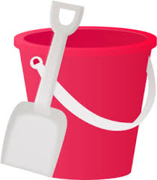 | Magnificently Medieval  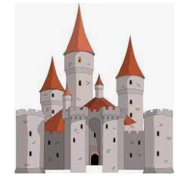 | Rotten Romans  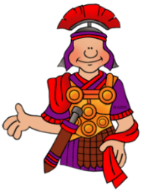 | Rotten Romans | Vicious Vikings | 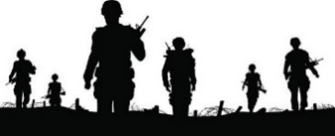  Woeful Wars
National Curriculum Objectives | *The lives of significant individuals in the past who have contributed to national and international achievements. Some should be used to compare aspects of life in different periods (e.g. Elizabeth I and Queen Victoria, Christopher Columbus and Neil Armstrong, William Caxton and Tim Bernes-Lee, Pieter Bruegel the Elder and LS Lowry, Rosa Parks and Emily Davison, Mary Seacole and/or Florence Nightingale and Edith Cavell).  *Identify similarities and differences between ways of life in different periods. | *Identify similarities and differences between ways of life in different periods.  *Significant historical events, people and places in their own locality. | *The Roman Empire and its impact on Britain. This could include:  ** Julius Caesars attempted invasion in 55-54 BC.  ** The Roman Empire by AD 42 and the power of its army.  ** Successful invasion by Claudius and conquest, including Hadrian’s Wall British resistance, e.g. Boudica.  ** “Romanisation” of Britain: sites such as Caerwent and the impact of technology, culture and beliefs, including early Christianity.  *Britain’s settlement by Anglo-Saxons and Scots. This could include:  ** Roman withdrawal from Britain in c. AD 410 and the fall of the western Roman Empire.  ** Scots invasions from Ireland to north Britain (now Scotland).  ** Anglo-Saxon invasions, settlements, and kingdoms: place names and village life.  ** Anglo-Saxon art and culture.  ** Christian conversion - Canterbury, Iona and Lindisfarne. | *The Roman Empire and its impact on Britain. This could include:  ** Julius Caesars attempted invasion in 55-54 BC.  ** The Roman Empire by AD 42 and the power of its army.  ** Successful invasion by Claudius and conquest, including Hadrian’s Wall British resistance, e.g. Boudica.  ** “Romanisation” of Britain: sites such as Caerwent and the impact of technology, culture and beliefs, including early Christianity.  *Britain’s settlement by Anglo-Saxons and Scots. This could include:  ** Roman withdrawal from Britain in c. AD 410 and the fall of the western Roman Empire.  ** Scots invasions from Ireland to north Britain (now Scotland).  ** Anglo-Saxon invasions, settlements, and kingdoms: place names and village life.  ** Anglo-Saxon art and culture.  ** Christian conversion - Canterbury, Iona and Lindisfarne. | *Britain’s settlement by Anglo-Saxons and Scots. This could include:  ** Roman withdrawal from Britain in c. AD 410 and the fall of the western Roman Empire.  ** Scots invasions from Ireland to north Britain (now Scotland).  ** Anglo-Saxon invasions, settlements, and kingdoms: place names and village life.  ** Anglo-Saxon art and culture.  ** Christian conversion – Canterbury, Iona and Lindisfarne.  A Viking and Anglo-Saxon struggle for the Kingdom of England to the time of Edward the Confessor. This could include:  ** Viking raids and invasion  ** Resistance by Alfred the Great and Athelstan, first king of England.  ** Further Biking invasions and Danegeld.  ** Anglo-Saxon laws and justice.  ** Edward the Confessor and his death in 1066. | *A study of an aspect or theme in British history that extends pupils’ chronological knowledge beyond 1066. For example:  ** The changing power of monarchs using case studies such as John, Anne and Victoria.  ** Changes in an aspect of social history, such as crime and punishment from the Anglo-Saxons to the present or leisure and entertainment in the 20th Century.  ** The legacy of Greek and Roman culture (art, architecture or literature) on later periods in British history, including present day.  ** A significant turning point in British history, e.g. the first railways or the Battle of Britain.
Key Facts to be taught  Key concept throughout: Change | *Similarities and differences between seaside towns now and in the Victorian era.  *Who Queen Victoria was.  *How our world has changed since the Victorian time | *What life in medieval times was like compared to now  *Who lived in castles and what they were used for.  *Compare different castles.  *Similarities and differences between medieval life and life today. | *What life was like in Roman Britain compared to now  *How Britain changed in Roman times.  *Why the Romans came to Britain.  *What the Roman Empire was and why it was so big.  *What Romans did for fun.  *How the Roman army was structured  *Roman Gods  *The story of Romulus and Remus.  *Roman gladiators | *What life was like in Roman Britain compared to now.  *How Britain changed in Roman times.  *Why the Romans came to Britain.  *What the Roman Empire was and why it was so big.  *What Romans did for fun.  *How the Roman army was structured  *Roman Gods  *The story of Romulus and Remus.  *Roman gladiators | *Know why the Vikings came to Britain.  *Understand what made the Vikings successful invaders.  *Know how the Vikings changed and influenced life in Britain.  *Understand how the Viking rule was brought to an end.  *Know why 1066 was such an important year for the Vikings. | *Key dates and people involved in wars over the last 1000 years.  *What happened during the Holocaust.  *What has changed because of war  *Current wars.
Skills to be taught | * Place events on a simple timeline  * Know and recount episodes from stories about the past, knowing and understanding key events  * Use stories to distinguish between fact and fiction and to remember key Historical facts  * Compare adults talking about their past – How reliable are their memories?  * Find answers to simple questions about the past from sources of information e.g artefacts and pictures  * Ask and answer simple Historical questions  * Communicate their knowledge through role play and making models | * Sequence artefacts closer together in time  *Place events on a simple timeline, adding times previously studied  * Identify differences between ways of life at different times  *Compare two versions of a past event  *Discuss the reliability of photos/accounts/stories  *Identify ways that the past is represented and discuss reliability of evidence e.g. photos, paintings, accounts, stories.  *Observe and handle sources and evidence to ask and answer questions about the past based on simple observations | *Place the time studied on a timeline, compare where this fits in to topics previously studied  * Identify reasons for and the results of people’s actions  *Understand why people may have wanted to do something  *Look at representations of the period e.g. Museum, cartoons  etc.  * Make connections and note the cause and effect in Historical periods studied  * Distinguish between different sources – compare different versions of the same story  * Select and record information relevant to the study  * Begin to use the internet and library for research  * Use historical terms to talk about passing time  * Begin to construct own responses that involve thoughtful selection and organisation of relevant Historical information | * Use evidence to reconstruct life in time studied  * Identify key features and events of time studied  * Begin to evaluate the usefulness of different sources  * Use textbooks and own growing Historical knowledge to gain a better perspective  * Use evidence to build up a picture of a past event  * Use the library and internet for research  * Communicate their knowledge through discussion, reading, writing and ICT | * Use relevant terms and period vocabulary  * Examine causes and results of great events and the impact on people  * Compare an aspect of life with the same aspect in another period  * Offer some reasons for different versions of events  *Answer and devise own Historically valid questions about change, cause, similarity and difference and significance  * Communicate their knowledge through relevant historical discussion, reading, writing and ICT | * Use relevant dates  * Explain a past event in terms of cause and effect using evidence to support and illustrate their explanation  * Know key dates, characters and events of time studied  * Be aware that different evidence will lead to different conclusions  * Consider ways of checking accuracy of interpretations – fact or fiction and opinion  * Communicate their knowledge through historical enquiry, reading, writing and ICT
Extended Writing Opportunity | Queen Victoria fact file | Diary of a knight | If I was a Roman God… | If I was a Roman God… | A Viking saga | Facts about the Holocaust

EYFS Development Matters
Reception | ELG
*Comment on images of familiar situations in the past.  *Compare and contrast characters from stories, including  figures from the past. | *Talk about the lives of people around them and their roles in society.  *Know some similarities and differences between things in the past and now, drawing on their experiences and what has been read in class.  *Understand the past through settings, characters and events encountered in books read in class and storytelling.

Topic | All About Me | Our World | Amazing Animals | Space | Superheroes | When I Grow Up
Key facts to be taught | *Talk about members of their immediate family and community  *Name and describe people who are familiar to them | *Compare and contrast characters from stories  *Draw information from a simple map  *Understand some places are special to people  *Recognise people have different beliefs  *Compare past and present Leicester/families | *Comment on images of familiar situations in the past  *Describe what they see, hear, and feel whilst outside  *Understand the effect of changing season  *Compare old and new animals (extinction) | *Explore the natural world around them  *Recognise some environments are different  *Understand the past through settings, characters and events | *Talk about the lives of people around them and their role  *Know similarities and differences between religious and cultural communities | *Understand some important processes and changes in the natural world  *To look back over the year
Key skills to be taught | *Remember and talk about significant events in their own lives  *Recognise and describe special times or events for family or friends | *Notice and talk about similarities and differences  *Ask and answer questions about the world around them  *Begin to use simple historical vocabulary to talk about the passing of time eg, once upon a time, a long time ago  *Compare past and present | *Ask and answer questions about the world around them  *Compare old and new | *Ask and answer questions about the world around them | *Ask and answer questions about the world around them | *Ask and answer questions about the world around them  *Begin to use simple historical vocabulary to talk about the passing of time eg, once upon a time, a long time ago

