Intent:
To describe the changes as humans develop to old age.

Year 5
Unit: Animals including Humans
Prior learning
Year 2 – Notice that animals, including humans, have offspring which grow into adults.

Later learning (not in Year 5)
KS3 – Reproduction in humans (as an example of a mammal), including the structure and function of the male and female reproductive systems, gestation and birth, to include the effect of maternal lifecycle on the foetus through the placenta.

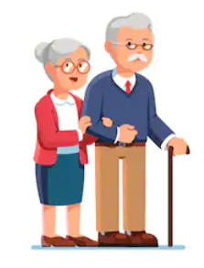
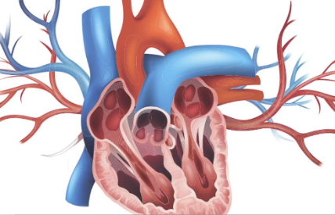
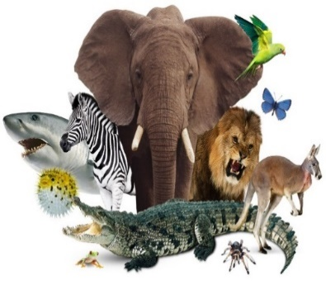

Vocabulary
Adolescence | The social and emotional stage of development between childhood and adulthood.
Adulthood | The stage of development when a human is fully grown and mature.
Development | The gradual growth or formation of something
Foetus | An animal or human being in its later stages of development before it is born.
Gestation | The process in which babies grow inside their mother’s body before they are born.
Growth | An increase in something.
Hormones | A chemical, usually occurring naturally in your body, that makes an organ in your body do something.
Infancy | The period of your life when you are a very young child.
Life cycle | The changes a living thing goes through, including reproduction.
Life expectancy | The length of time, on average, that a particular animal is expected to live.
Mature | When a child or young animal matures, it becomes an adult.
Menopause | The time during which a woman gradually stops menstruating, usually when she is about 50 years olf.
Menstruation | The approximately monthly discharge of blood by non-pregnant women from puberty to menopause.
Offspring | A person’s children or an animal’s young.
Organ | A part of your body that has a particular purpose.
Puberty | The physical stage of development between childhood and adulthood.
Toddler | A young child who has only just learned to walk.

Key Questions:
What is the gestation period for humans?
What are the 6 stages of human life?
Which stage of the human life cycle comes before childhood?
At which stage of the human life cycle does the body change so that reproduction can occur?
What is life expectancy?

