2023-2024
Phonics across the school
An overview of RWI AND PHONICS DELIVERY ACROSS THE SCHOOL
Luka Moscetano

Willowbrook Mead Primary Academy- Phonics 23-24

Nursery:
Our children usually enter lower than National in our nursery year. We often find that communication and language is low and many of the children require a rich vocabulary and opportunities to listen and talk in groups.
- The focus of the year is communication and language.
- Teachers focus on activities that develop environmental sounds, voice sounds, body percussion, rhyme, and listening to initial sounds.
- The children begin to learn set 1 sounds in the summer term to prepare them for reception
The nursery pre-phonics plan allows for progression throughout the year in listening and oracy skills.
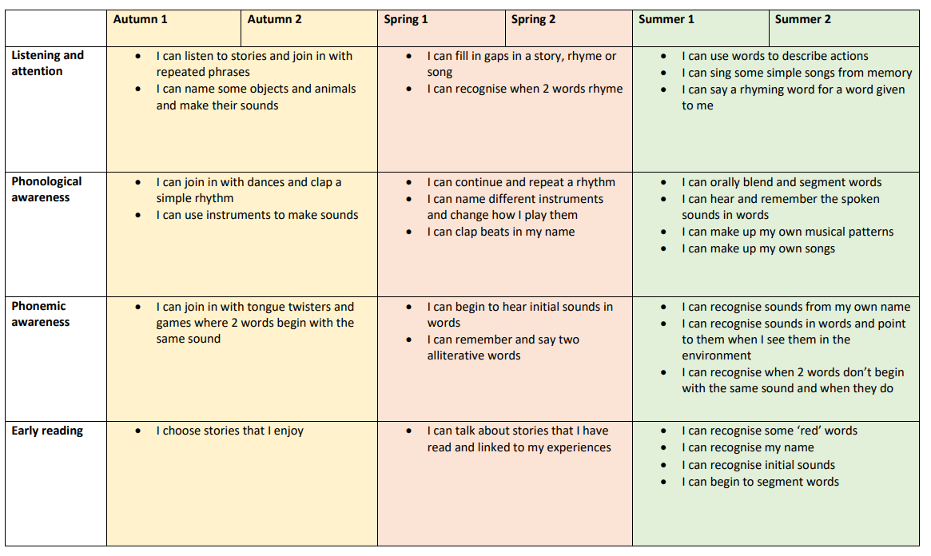
Lesson structure:
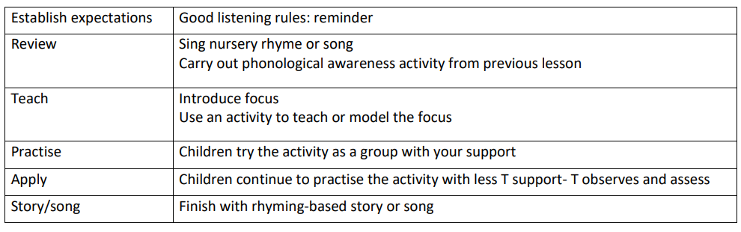

Read Write Inc Phonics programme
Summary of progression of the teaching of sounds
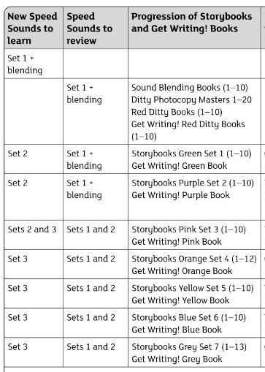

Reception:
Our reception children start lower than average, especially in communication and language. However, they make excellent progress throughout the year. Phonics is taught daily, and teachers identify the children that need extra support/intervention. The children have whole class phonics with a class teacher and teaching assistant. At Christmas, they are assessed using the RWI assessment and split into ability groups across the year group. Children who are not picking up the new sounds will receive one to one ‘keep up sessions during the afternoon.
The children learn their sounds and complete ‘word time’. When groups can blend, they can move on to ditty sheets and red ditties. They then follow the below timetable:
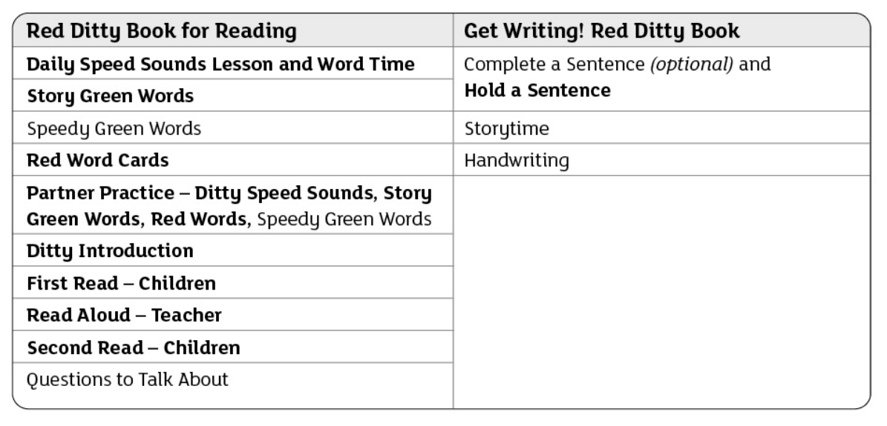

Year 1-6
Children in year 1 and the bottom 20% readers in years 2 to 6 completed a RWI entry assessment to determine which group they need to be in. Phonics is delivered as a curriculum across the school at the same time, so children build their reading and writing skills to be able to access the curriculum.
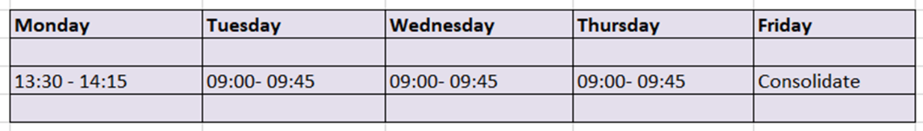
The lesson structure will be dependent on the group and follow the RWI scheme. Children will have the opportunity to read and write each session and build on their fluency and comprehension skills. The reading lead and assessment lead will ensure that at each data point, the children are tracked and identify any gaps.

The Willow (DSP)
The children in the DSP have daily phonics sessions and follow an adapted RWI timetable which is shown below:
Monday | Tuesday | Wednesday | Thursday | Friday
Introduce new sound – daily speed sound lesson  Writing of words | Red and green words | Storybook session 1- introduce the book, 1st read | Storybook session 2 – children read, comprehension activities. Model hold a sentence and writing it. | Hold a sentence writing (independent)

Assessment
Formative assessment
Teachers continually assess the children and will ‘catch up’ children during afternoons. Phonics groups are also fluid and teachers will often discuss and monitor progress. Teachers regularly expose them to sound cards throughout the day. In year 1, children will read ‘red’ words throughout the day and will be exposed to sounds in stories and text.
Summative assessment
Teachers complete the RWI assessment every half term. Depending on the children’s ability they will then group the children according to their reading progress. The below table shows the starting point for each group depending on their assessment score.
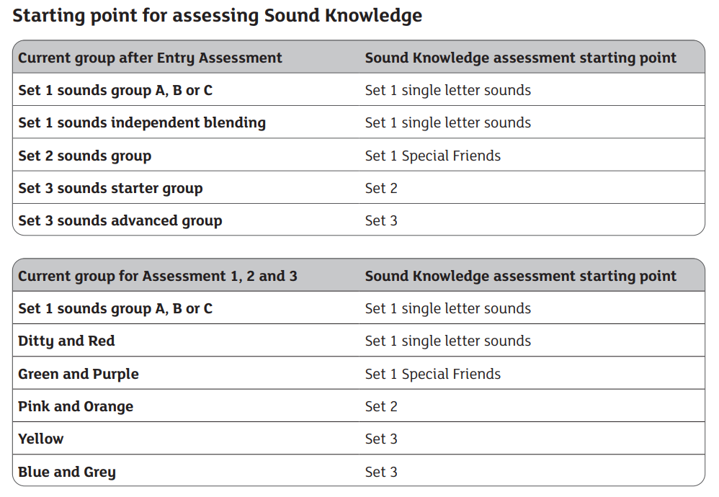

In preparation for the year 1 phonics screening check, teachers will closely monitor assessment and data to ensure that children are on track to pass. Those who are not on track will receive additional interventions to support them.

Monitoring
The reading lead completes phonics learning walks weekly and regular book match checks to ensure accuracy.
Teachers are also asked to track their lowest 20% readers at each data point to ensure that gaps are being closed and the correct intervention is in place.

1:1 reading

All bottom 20% readers are read with every day. They are encouraged to talk about their book and learn about basic print concepts. 1:1 session follows the structure:

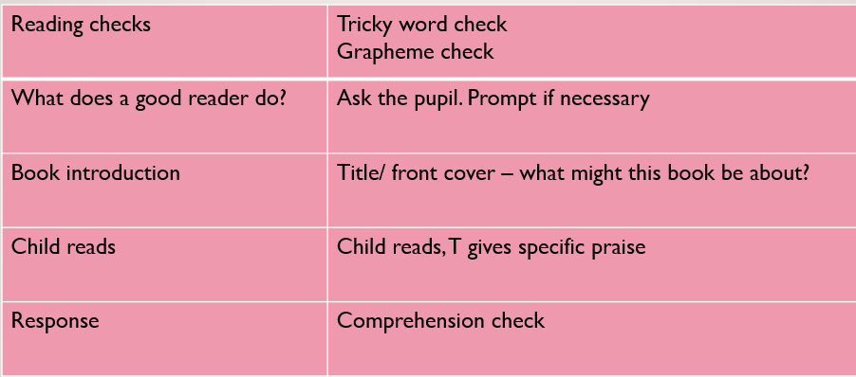

Reading at home
The children will take home their phonics reading book once they have read them in their phonics groups. This will allow them to confidently read them at home with their families. Parents will be reminded that these books are closely matched to their phonics ability.
Children will be encouraged to share other books at home but will understand that their reading book is their RWI book.
We have Oxford Reading buddy for lower KS1 and Accelerated Reader for upper KS1 and KS2. This allows children to read books online and complete quizzes and build on their comprehension skills.

