2023
Phonics across the school
An overview of RWI AND PHONICS DELIVERY ACROSS THE SCHOOL
Luka Moscetano

Willowbrook Mead Primary Academy- Phonics 22-23

Nursery:
Our children usually enter lower than National in our nursery year. We often find that communication and language is low and many of the children require a rich vocabulary and opportunities to listen and talk in groups.
- The focus of the year is communication and language
- Teachers focus on activities that develop environmental sounds, voice sounds, body percussion, rhyme, and listening to initial sounds.
- The children begin to learn set 1 sounds in the summer term to prepare them for reception
The nursery pre-phonics plan allows for progression throughout the year in listening and oracy skills.
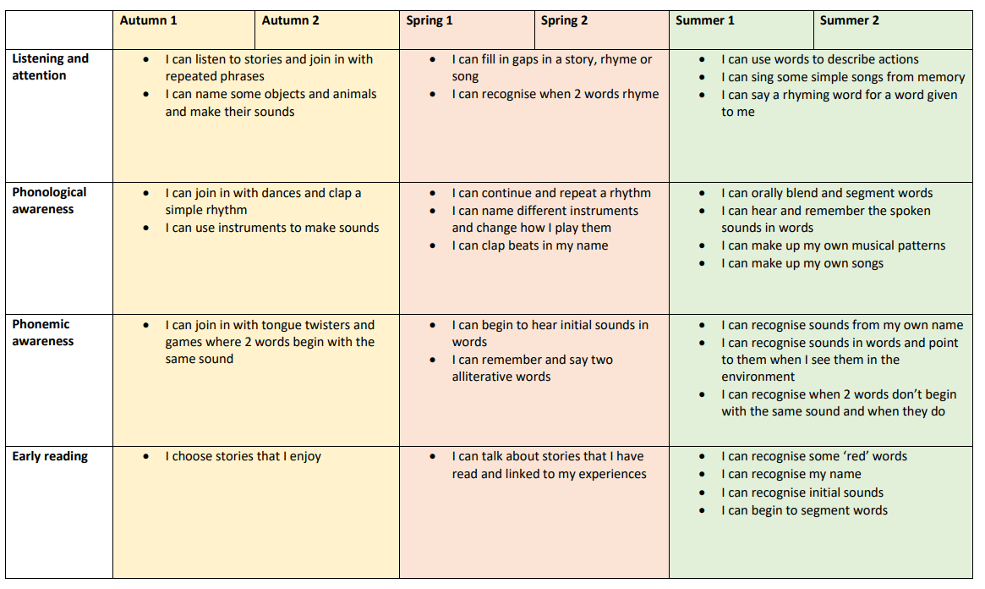
Lesson structure:
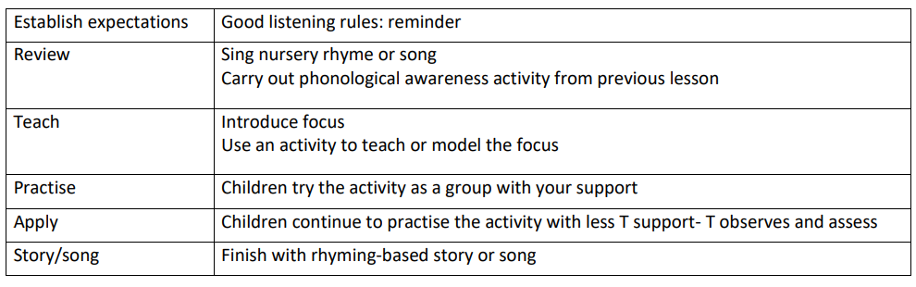

Read Write Inc Phonics programme
Summary of progression of the teaching of sounds
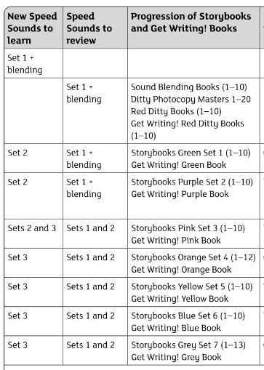

Reception

Year 1

Reception:
Our reception children start lower than average, especially in communication and language. However, they make excellent progress throughout the year. Phonics is taught daily, and teachers identify the children that need extra support/intervention. The children are split into ability groups.
- 5 phonics sessions a week
- A weekly ‘guided write’ session
- Daily opportunities to practise sounds and red words
- RWI assessment completed every half term to monitor progress
The children learn their sounds and complete ‘word time’. When groups can blend, they can move on to ditty sheets and red ditties. They then follow the below timetable:
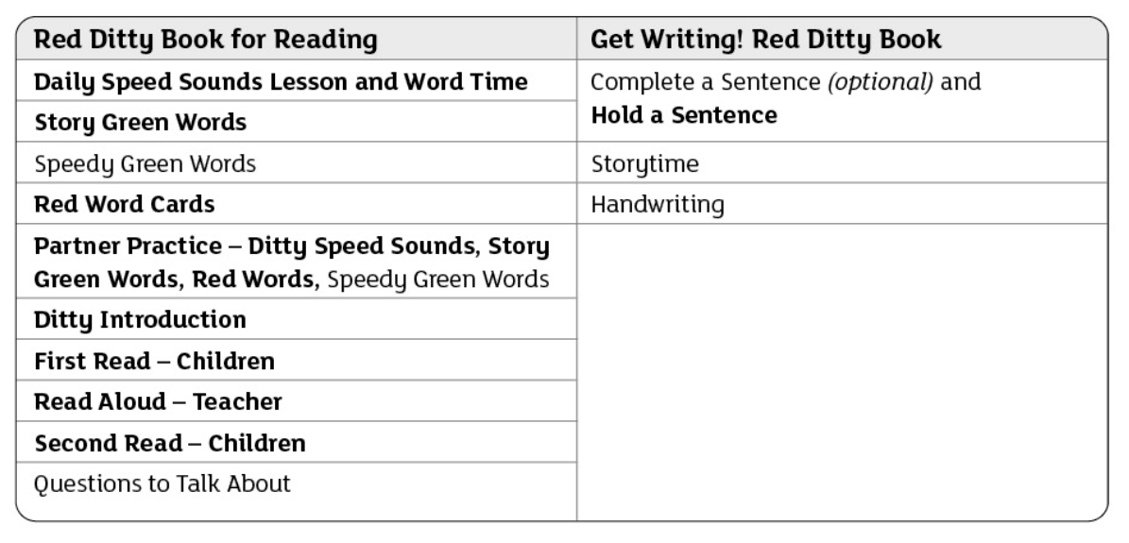

Year 1
The main focus of year 1 is to prepare the children for the phonics screening check and to ensure that they are confident readers and writers moving on to year 2. Children are split into ability groups.
- 5 phonics sessions a week
- Lowest 20% readers have weekly 1:1 reading session
When children move onto the green ditty books, they move onto the following timetable:
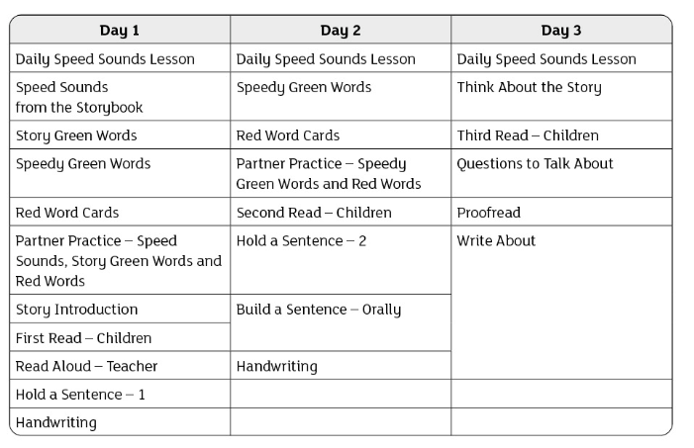

Year 2
Year 2 review the set 1,2 &3 sounds in the Autumn term before moving onto spelling rules and accessing the RWI ‘get spelling’ resources.

- Class teacher and TA deliver whole class phonics
- Children who did not pass PSC in year 1 will access daily intervention
- Children will move onto MyOn for reading (children in intervention will remain on RWI ditty book)

Year 2 also follow the ‘RWI spelling’ programme as a natural progression from the RWI phonics scheme.

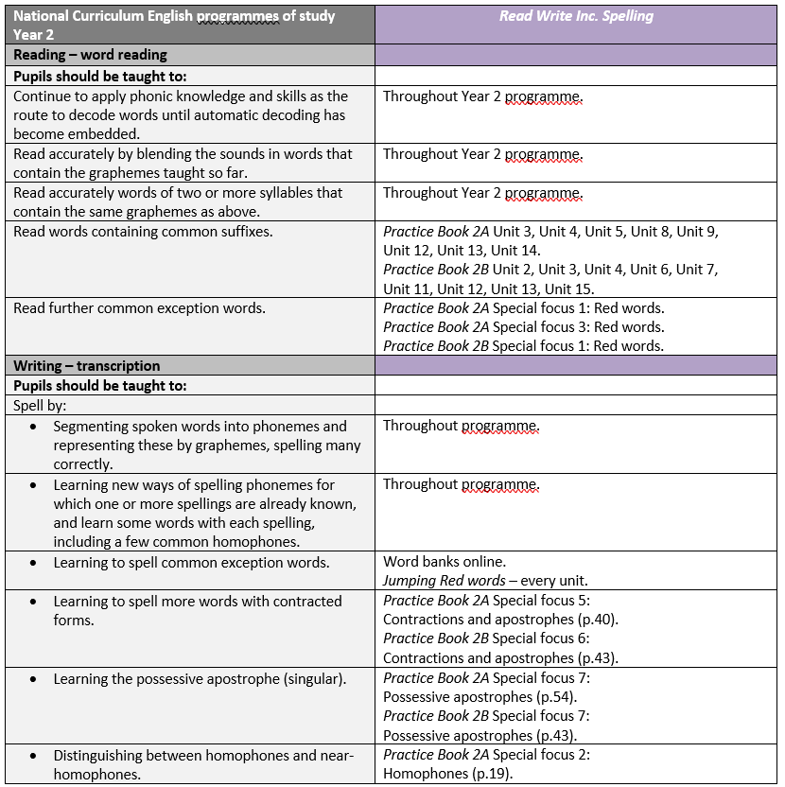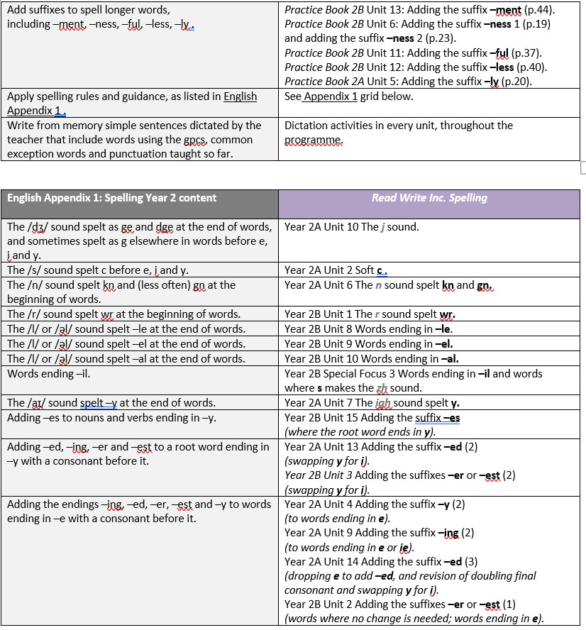

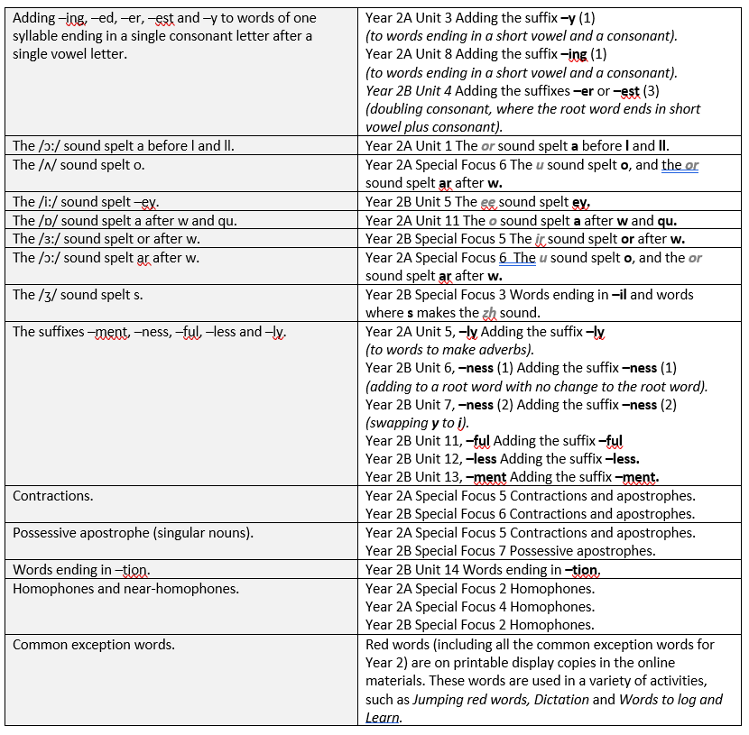

Interventions
Children who have not passed their phonics screening check, have a phonics session following the year 1 timetable. This includes a reading and writing element in every session. The children have been grouped in terms of their phonics ability. An interventions TA works with these children daily to ensure that the children make accelerated progress.

Year 3/4
The children follow the RWI spellings programme:
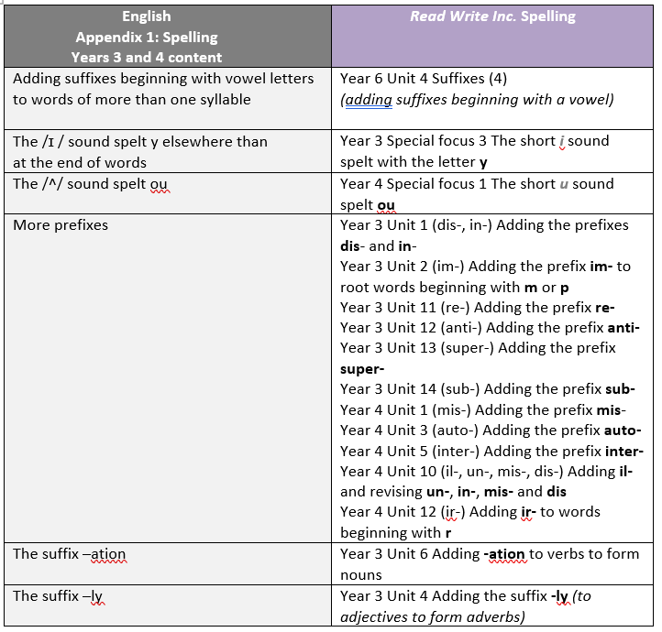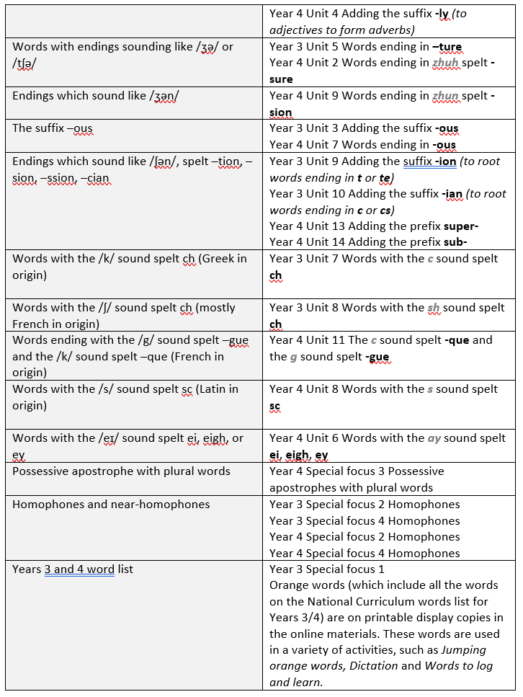
Interventions:
Pupils who have not passed the phonics retake in Year 2 will need to continue to receive intervention to close this gap in their learning. This intervention will also be appropriate for any EAL children entering the school mid-year and needing support with their phonics.
The intervention will consist of a small group daily phonics intervention.
Each pupil will be assessed at the start and end of the intervention programme using both the Benchmarking assessment and RWI phonics assessment.
Once pupils have completed the programme and passed the phonics threshold, they will move onto using Accelerated Reader and accessing the Star Reader assessments. They will also be required to be on the ‘Daily Readers’ list and ensure the read with an adult every day. This will ensure the impact of the intervention is sustained.
If pupils fail to make progress after the 8-week intervention, they will need to be assessed again by the reading lead and Sendco to identify whether there are further underlying barriers to learning that have not yet been addressed.

Year 5/6
Weekly spelling focus where the children watch the spelling videos and complete work in their RWI spelling books. In addition, the children have weekly spelling tests.
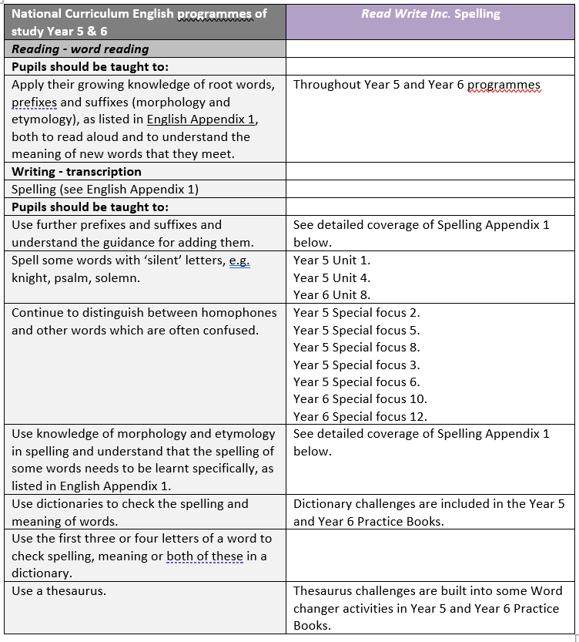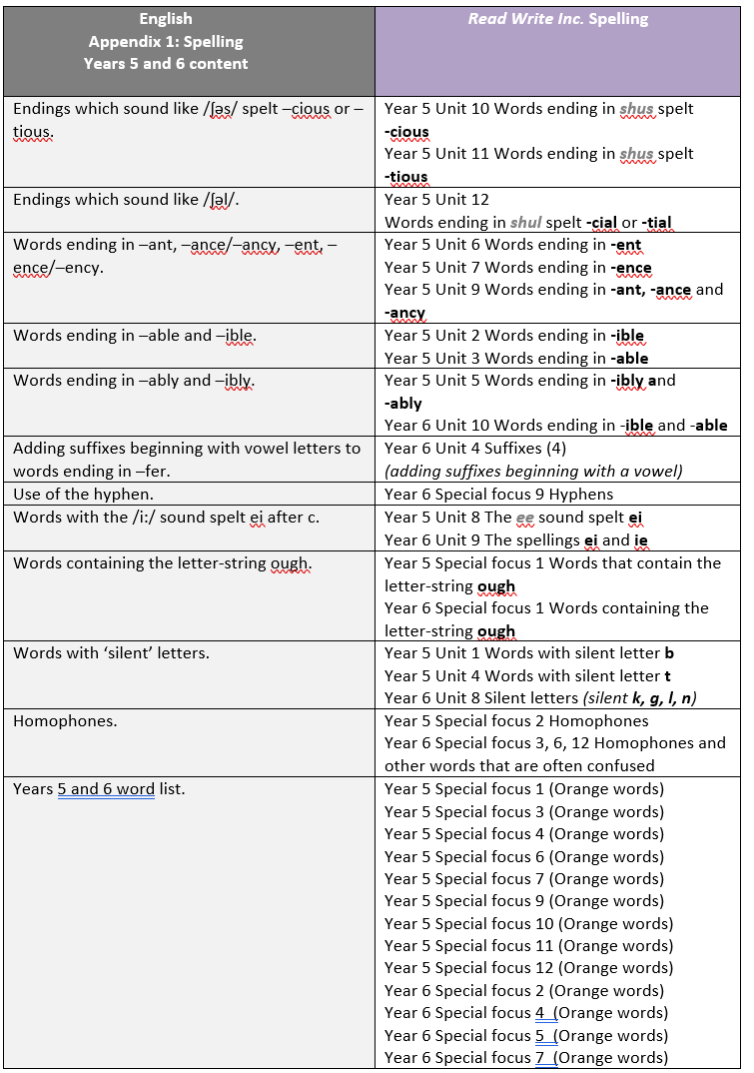

DSP
The children in the DSP have daily phonics sessions and follow an adapted RWI timetable which is shown below:
Monday | Tuesday | Wednesday | Thursday | Friday
Introduce new sound – daily speed sound lesson  Writing of words | Red and green words | Storybook session 1- introduce the book, 1st read | Storybook session 2 – children read, comprehension activities. Model hold a sentence and writing it. | Hold a sentence writing (independent)

Assessment
Formative assessment
Teachers continually assess the children and will ‘catch up’ children during afternoons. Phonics groups are also fluid and teachers will often discuss and monitor progress. Teachers regularly expose them to sound cards throughout the day.
Summative assessment
Every half term, teachers assess the children on their sounds and red words. The year 1 children also complete practise PSC to identify gaps. The phonics lead then monitors this data and interventions are delivered where needed and planning is adapted to ensure that children do not fall behind.

