Autumn 1
Intent:
To learn about self-regulation To learn about resilience
To build confidence in an unfamiliar setting To show kindness to my friends

Book focus:
- Pete the Cat

Suggested books:
-The Large Family
-The Family Book

Magnificent Me
Pictures:
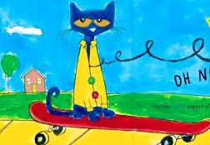

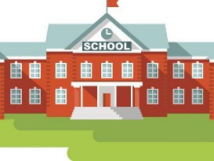
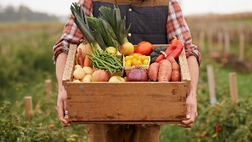
Skills:
Reading:
- I can make the noise of a range of animals and environmental objects
- I can explore the sound of instruments and link them to actions in stories
Writing:
- I can make a mark with media
Maths:
- I can sort objects according to colour, size and shape
Understanding of the world:
- I can talk about my family and share stories about us

Enrichment:
School tour
First visit to the Outdoor classroom
Bread making – Harvest

Key Questions:
- What does resilience mean?
- How can you be a kind friend?
- Which area of the classroom do you like best?
- Can you express how you are feeling today?
- What does your family look like?
- Who do you live with?
- Can you name some things that you do with your family?

Careers:
Ask your family what careers/jobs they do. How many different careers can you name?

Resilience: the ability to recover quickly from difficulties | Self-regulation: the ability to understand and manage your behaviour and your reactions to feelings and things happening around you | Rules: something that tells us what to do | Boundaries: the limits of behaviour | Feelings: an emotional state or reaction | Emotions: a strong feeling that comes from your mood
Senses: how the body perceives an external stimulus (touch, taste, sight, hear, smell) | Family: a group of one or more parents with their children | Friends: a person you make a bond with | Rewards: something given in return for good work/behaviour | Behaviour: the way you act | Kind: showing helpful and caring behaviour towards others
Helpful: giving or ready to give help to someone | Confidence: the feeling that you can do something well | Harvest: gathering crops
Key Vocabulary

