**Autumn 1**

**Intent:**

To learn about self-regulation To learn about resilience

To build confidence in an unfamiliar setting To show kindness to my friends

**Book focus:**   
- Pete the Cat

**Suggested books:**

-The Large Family

-The Family Book

**Magnificent Me**

**Pictures:**

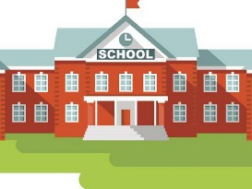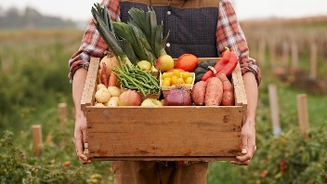

**Skills:**

Reading:

* Retell a story in role play
* Use pictures to make up a storyline

Writing:

* Make marks with different media
* Give meaning to my marks

Maths:

* Recognise the routine of a school day
* Begin to count objects to 10
* Name 2D shapes

Understanding of the world:

* Recognise similarities and differences between families

**Enrichment:**

School tour

First visit to the Outdoor classroom

Bread making – Harvest

**Key Questions:**

* What does resilience mean?
* How can you be a kind friend?
* Which area of the classroom do you like best?
* Can you express how you are feeling today?
* What does your family look like?
* Who do you live with?
* Can you name some things that you do with your family?

**Careers:**

Ask your family what careers/jobs they do. How many different careers can you name?

|  |  |  |  |  |  |
| --- | --- | --- | --- | --- | --- |
| Resilience: the ability to recover quickly from difficulties | Self-regulation: the ability to understand and manage your behaviour and your reactions to feelings and things happening around you | Rules: something that tells us what to do | Boundaries: the limits of behaviour | Feelings: an emotional state or reaction | Emotions: a strong feeling that comes from your mood |
| Senses: how the body perceives an external stimulus (touch, taste, sight, hear, smell) | Family: a group of one or more parents with their children | Friends: a person you make a bond with | Rewards: something given in return for good work/behaviour | Behaviour: the way you act | Kind: showing helpful and caring behaviour towards others |
| Helpful: giving or ready to give help to someone | Confidence: the feeling that you can do something well | Harvest: gathering crops |  |  |  |

Key Vocabulary