Autumn 2
Book focus:
- Room on the Broom
- Rama and Sita
- The Nativity

Suggested books:
- Funny Bones

Intent:
To be aware of the community and world around me
To learn about Christian celebrations and compare to other religions

Our Wonderful
World
Pictures:
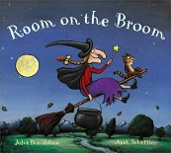

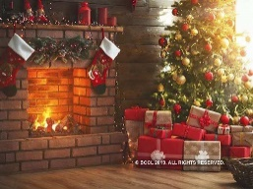
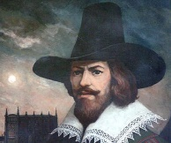
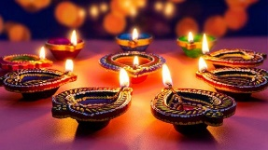
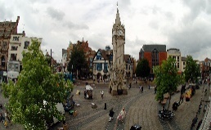
Skills:
Reading:
- Use pictures to make up a storyline
- Begin to hear sounds and orally blend
Writing:
- Give meaning to my marks
- Begin to write initial sounds
Maths:
- Understand one more and one less
- Explore the composition of numbers to 10
Understanding of the world:
- Recognise that people have different beliefs and celebrate different times

Careers:
- Tour guide
- Bus driver
- Events planner
- Priest
- Granthi
- Pandit/Pujari

Key Questions:
- Do you celebrate Halloween?
- Who was Guy Fawkes?
- Who celebrates Diwali?
- What do you celebrate at home?
- Where do you live?
- What is the name of the street you live on?
- Can you name any shops/amusements in your local area?
- Do you recognise any landmarks from Leicester?
- Who celebrates Christmas?

Enrichment:
Bonfire
Diwali Day
Nativity performance
Pantomime

Key Vocabulary

Halloween: celebrated by going trick or treating | Diwali: the Hindu and Sikh celebration of light | Father Christmas: lives in the North Pole and delivers presents to good boys and girls | Nativity: the story of Baby Jesus | Christmas: the Christian celebration of Jesus’ birth | City: a place where a large number of people live close together
Leicester: a city in England where we live | Diva Lamps: a special lamp used in the festival of light | Rangoli Pattern: a decoration that is made for Diwali | Guy Fawkes: a man in history who instigated the gun powder plot | Bonfire Night: the celebration of capturing Guy Fawkes | Jesus: the son of God
Landmark: a well-known feature in an town/city

