Spring 1
Book focus:
- Goodnight Spaceman

Suggested books:
- Toys in Space
- Aliens love Underpants
- Whatever Next!
- Look up

Intent:
- To learn about our universe
- To understand the world around us

EYFS- Space
Pictures:

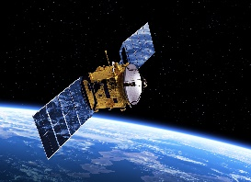
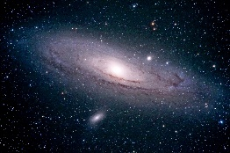
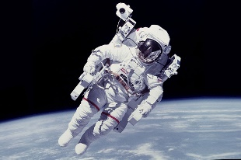
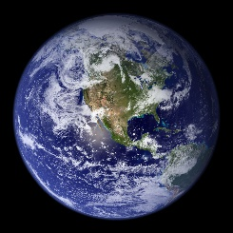
Skills:
Reading:
I can name different parts of a book
I can clap syllables

Writing:
I can write some letters in my name
I understand that print has different meanings

Maths:
I can count objects up to 3 – saying numbers in order
I can represent the numbers 1-3 in different ways. E.g. finger representation, numeral, tally marks, pictures, objects and on a 5’s frame.
I can subitise up to 3
Understanding of the world:
I can talk about what they see, using a wide vocabulary
I can explore the natural phenomena in their setting

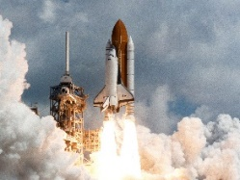
Careers:
- Astronaut
- Space suit designer
- Engineer
- Astronomer
- Space research

Enrichment:
- Google expedition
- Science experiments
- Space Centre

Key Questions:
- What is the solar system?
- How many planets are in our solar system?
- How do astronauts shower in space?
- Do you know any famous astronauts?
- If you went to space, what would you take?
- Can we live on any planet? Why?
- Are aliens real?

Alien – a creature that may live in space | Astronaut - a person who has been to space | Asteroid – is a small rocky object that orbits the sun | Galaxy – is made up of gas and dust which is held together by gravity | Solar system – there are 8 planets all together which make up our solar system. | Gravity – is a force that pulls everything together.
Expedition – a group of people that take a journey to explore | Earth – is the planet we live on. It is made of land and water. | Shooting star – is a meteorite that has fallen into the Earth’s atmosphere. | Atmosphere – is a gas that covers the Earth. | Sun – is a star at the centre of our solar system | International Space Station (ISS) - is a large space craft that orbits Earth. Astronauts complete their jobs in here.
Spacewalk – when the astronaut goes out of the space shuttle to work | Planet – it must be a sphere, gas gravity and orbits the sun | Orbit – this is when the plants move around the sun | Meteorite – are made up from asteroids
Key Vocabulary

