Spring 1
Book focus:
- Goodnight Spaceman

Suggested books:
- Toys in Space
- Aliens love Underpants
- Whatever Next!
- Look up

Intent:
- To learn about our universe
- To understand the world around us

EYFS- Space
Pictures:

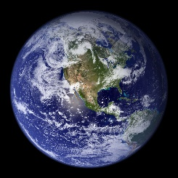
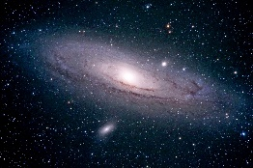
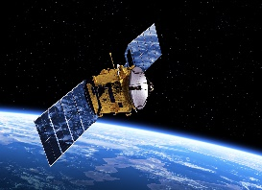
Skills:
Reading:
Writing:
Maths:
Understanding of the world:

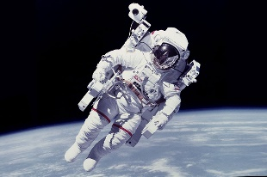
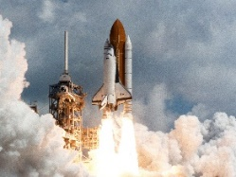
Enrichment:
- Google expedition
- Science experiments
- Space Centre

Careers:
- Astronaut
- Space suit designer
- Engineer
- Astronomer
- Space research

Key Questions:
What is the solar system?
How many planets are in our solar system?
How do astronauts shower in space?
Do you know any famous astronauts?
If you went to space, what would you take?
Can we live on any planet? Why?
Are aliens real?

Alien – a creature that may live in space | Astronaut - a person who has been to space | Asteroid – is a small rocky object that orbits the sun | Galaxy – is made up of gas and dust which is held together by gravity | Solar system – there are 8 planets all together which make up our solar system. | Gravity – is a force that pulls everything together.
Expedition – a group of people that take a journey to explore | Earth – is the planet we live on. It is made of land and water. | Shooting star – is a meteorite that has fallen into the Earth’s atmosphere. | Atmosphere – is a gas that covers the Earth. | Sun – is a star at the centre of our solar system | International Space Station (ISS) - is a large space craft that orbits Earth. Astronauts complete their jobs in here.
Spacewalk – when the astronaut goes out of the space shuttle to work | Planet – it must be a sphere, gas gravity and orbits the sun | Orbit – this is when the plants move around the sun | Meteorite – are made up from asteroids
Key Vocabulary

