Spring 2
Book focus:
-

Suggested books:
- The Gruffalo – Julia Donaldson
- What the Ladybird heard – Julia Donaldson
- Rumble in the Jungle – Giles Andrea
- Commotion in the ocean - Giles Andreae

Intent:
- To learn about different animals from around the world
- To learn about animal habitats

EYFS- Animals
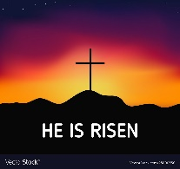
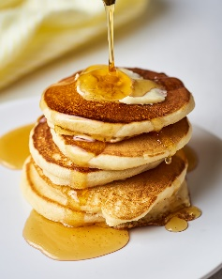
Pictures:

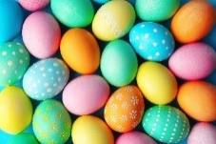
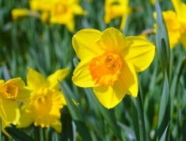
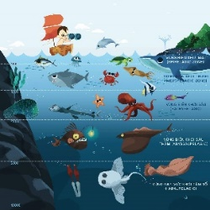
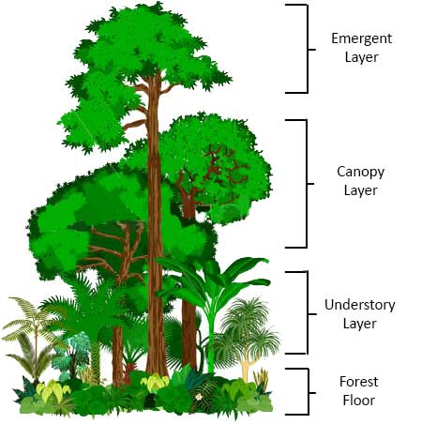
Skills:
Reading:
I can notice and repeat rhymes in stories
I can listen to a longer story

Writing:
I can make letter like shapes and writing
I can give meaning to different types of writing and drawing

Maths:
I can count objects up to 5 – saying numbers in order
I can represent the numbers 4-5 in different ways. E.g. finger representation, numeral, tally marks, pictures, objects and on a 5’s frame.
I can subitise up to 5
Understanding of the world:
I can care for living animals
I can talk about life cycles
I know there are different countries in the world

Careers:
- Farmer
- Marine biologist
- Pet shop
- Dog trainer/ walker
- Beekeeper

Enrichment:

Key Questions:
- What are the names of baby farm animals?
- What food can be made from milk?
- What does a farmer do?
- How celebrates Easter?
- What is lent?
- How many animals can you name that are amphibians, reptiles, mammals and invertebrates?

Fertiliser – is added to soil to help plants grow | Forest floor – this is where all the roots and soil are in the jungle | Canopy – the jungle is made up of different layers of trees that are different heights. | Deforestation – is where trees are cut down and jungles then become smaller | Resurrection – the rising of Jesus | New life – when an offspring is born
Dairy – is food that made from milk | Decay – is the rotting of aged natural objects | Amphibian – needs water to live | Habitat – is where an animal lives | Easter – a celebration of Jesus’ life | Life cycle – the stage of an animals life
Meadow – is a field that is used to grow hay | Mammal – needs air to breathe and has a back bone | Reptile – live in warm conditions because they are cold blooded | Invertebrates – these animals tend to live in the sea and they do not have any or many bones. | Christianity – a religion that believe in Jesus | Spring – a season where new life begins
Key Vocabulary

