**Su**m**mer 1**

**Book focus:**   
- Supertato

**Suggested books:**

* Super worm
* Super Daisy
* Captain Tom

**Intent:**

* To learn about real life people who can help us
* To learn how to become more altruistic (help others and be kind without needing a reward/ because someone asked you to)

**Superheroes**

**Pictures:**





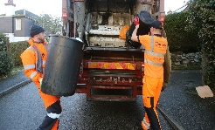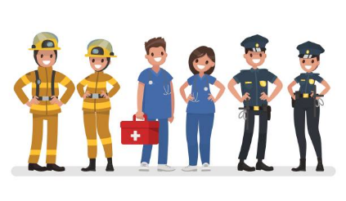

**Skills:**

Reading:

* Recognise sounds
* Say the initial sound for words
* Read learnt sight words

Writing:

* To write from left to right
* I can write my name

Maths:

* Problem solving with numbers to 10
* Comparing weight/ length and height

Understanding of the world:

* Show an interest in different occupations

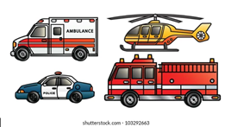

**Careers:**

* Doctor
* Nurse
* Police
* Vet
* Fire service

**Enrichment:**

Visits from real life superheroes

**Key Questions:**

* How do people help us?
* Why should we help people?
* What does it mean to help?
* How can you be like a superhero?
* What would your superhero power be?
* Who could you call in an emergency?
* What number would you call in an emergency?
* What skills do you need to be a superhero?

|  |  |  |  |  |  |
| --- | --- | --- | --- | --- | --- |
| Altruism: selfless concern for the wellbeing of others | Police: Responsible for the prevention and detection of crime to keep people safe | Doctor: A person who is qualified to treat people who are ill | Firefighter: A person whose job is to extinguish fires | Paramedic: A person who is trained to give emergency medical care to people injured or ill | Ambulance: A vehicle equipped for taking people who are injured or sick to and from hosiptal |
| 999: The number called in an emergency to reach police/ fire and ambulance services | Emergency: A serious unexpected and often dangerous situation requiring immediate action | Uniform: The clothing worn by members of the same organisation | Selflessness: Concerned more about the needs and wishes of others | Honesty: Telling the truth | Patient: A person receiving medical treatment |
| Inclusive: Not excluding anyone | Risk-taking The action of taking risks | Compassion: Showing concern for people who are in need. |  |  |  |

Key Vocabulary