Summer 2
Book focus:
- Oliver’s vegetables
- The tiny seed

Suggested books:
- Tadpoles promise
- Hungry caterpillar
- When I grow up

Intent:
- To learn about the lifecycle of a plant and animal
- To observe changes over a time
- To prepare for year 1

Growing and
Pictures:

changes
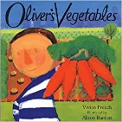
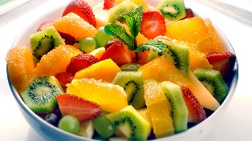
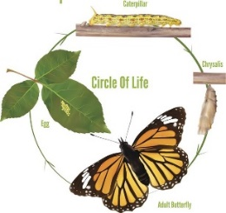
Skills:
Reading:
- Read simple captions
- Recognise sounds including digraphs
- Read sight words
Writing:
- Writing a simple caption
- Using a capital letter, finger spaces and a full stop
Maths:
- Problem solving with numbers to 10
- Comparing weight/ length and height
- Addition and subtraction
Understanding of the world:
- Understand a plant and animal lifecycle

Enrichment:
Visit to garden centre
Vist to a farm
Careers:
- Farmer
- Chef

Key Questions:
What is a plant?
What do plants need to grow?
How do tadpoles grow?
Where do tadpoles come from?
What do tadpoles grow into?
Why do we need to eat healthy foods?
Can you name some healthy foods?
When you grow up, what job would you like to do?

Life cycle – the different stages of an animal growing | Tadpole – 2nd stage of a frogs’ life cycle. These are hatched from frogspawn. | Chrysalis - is the process of how a butterfly or moth is born | Seed dispersal – when the seed moves away from the parent plant | Food groups – food is sorted into groups.  Carbohydrates, vegetables and fruit, fats, protein and dairy. | Grow – the change where someone or something gets bigger
Nutrients – something that provides another nourishments to help grow. | Being healthy – to eat food from different food groups. | Frogspawn – the first stage of how frogs grow | Plants – a seed or bulb that grows in the ground. That grows food or flowers. | Fruit – this is grown from a flowering plant. | Froglet – 3rd stage of a frogs’ life cycle. Grows arms and legs.
Grown up – becoming older or an adult | Amphibian – an animal with no back bone who can live on land and in water. | Insects – is a small animal with 6 legs and wings. | Vegetable – that is grown with a stem, roots and leaves. | Transition – moving from one class to another
Key Vocabulary

