**Su**m**mer 2**

**Book focus:**   
- Oliver’s vegetables  
- The tiny seed

**Suggested books:**

* Tadpoles promise
* Hungry caterpillar
* When I grow up

**Intent:**

* To learn about the lifecycle of a plant and animal
* To observe changes over a time
* To prepare for year 1

**Growing and**

**Pictures:**

**changes**

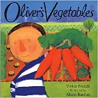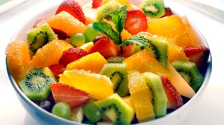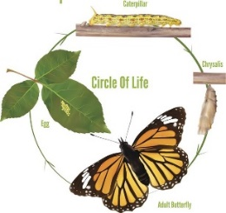

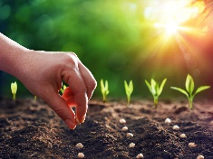

**Skills:**

Reading:

* I can recognise familiar letters that I have learnt and from my name in books
* I can act out stories and change parts to create my own story

Writing:

* I can write learnt letters

Maths:

* Comparing weight/ length and height
* Talk and recognise properties of 2D shapes

Understanding of the world:

* Understand a plant and animal lifecycle

**Enrichment:**

Visit to garden centre   
Visit to a farm

**Careers:**

* Farmer
* Chef

**Key Questions:**

What is a plant?

What do plants need to grow?

How do tadpoles grow?

Where do tadpoles come from?

What do tadpoles grow into?

Why do we need to eat healthy foods?

Can you name some healthy foods?

When you grow up, what job would you like to do?

|  |  |  |  |  |  |
| --- | --- | --- | --- | --- | --- |
| Life cycle – the different stages of an animal growing | Tadpole – 2nd stage of a frogs’ life cycle. These are hatched from frogspawn. | Chrysalis - is the process of how a butterfly or moth is born | Seed dispersal – when the seed moves away from the parent plant | Food groups – food is sorted into groups.  Carbohydrates, vegetables and fruit, fats, protein and dairy. | Grow – the change where someone or something gets bigger |
| Nutrients – something that provides another nourishments to help grow. | Being healthy – to eat food from different food groups. | Frogspawn – the first stage of how frogs grow | Plants – a seed or bulb that grows in the ground. That grows food or flowers. | Fruit – this is grown from a flowering plant. | Froglet – 3rd stage of a frogs’ life cycle. Grows arms and legs. |
| Grown up – becoming older or an adult | Amphibian – an animal with no back bone who can live on land and in water. | Insects – is a small animal with 6 legs and wings. | Vegetable – that is grown with a stem, roots and leaves. | Transition – moving from one class to another |  |

Key Vocabulary