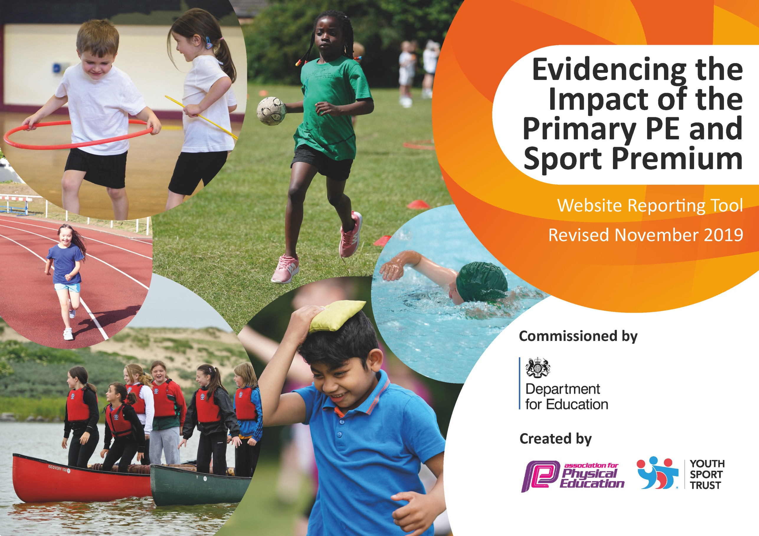
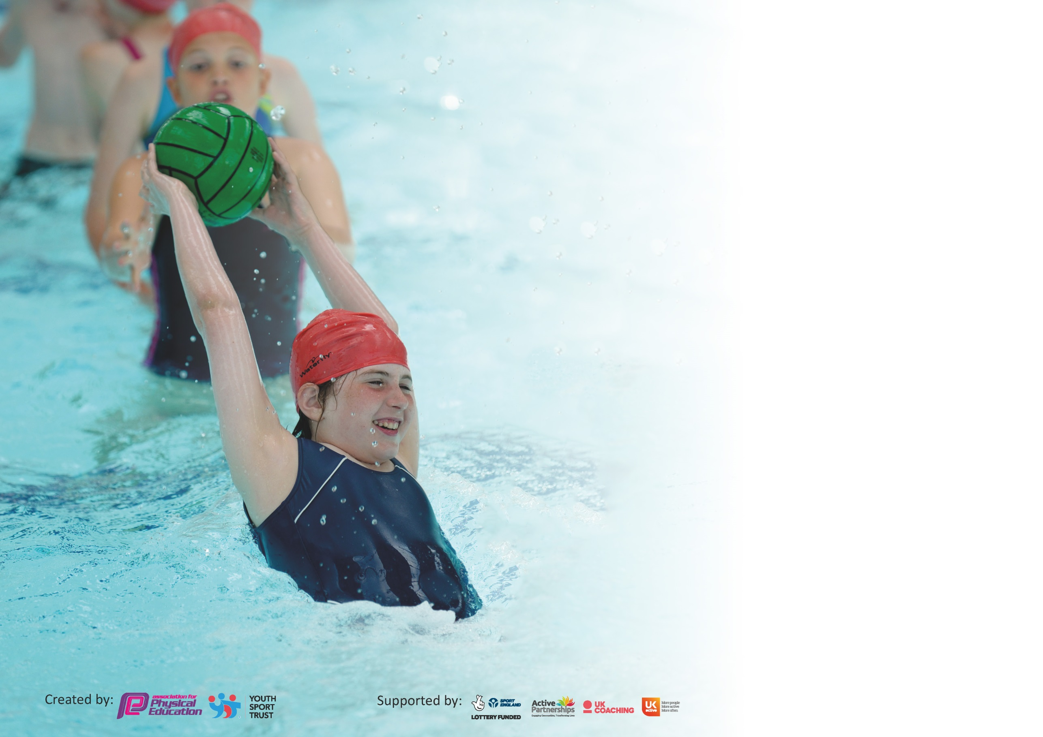

It is important that your grant is used effectively and based on school need. The Education Inspection Framework (Ofsted 2019 p64) makes clear there will be a focus on ‘whether leaders and those responsible for governors all understand their respective roles and perform these in a way that enhances the effectiveness of the school’.

Under the Quality of Education criteria (p41) inspectors consider the extent to which schools can articulate their curriculum (INTENT), construct their curriculum (IMPLEMENTATION) and demonstrate the outcomes which result (IMPACT).

To assist schools with common transferable language this template has been developed to utilise the same three headings which should make your plans easily transferable between working documents.

Schools must use the funding to make additional and sustainable improvements to the quality of Physical Education, School Sport and Physical Activity (PESSPA) they offer. This means that you should
use the Primary PE and Sport Premium to:

- Develop or add to the PESSPA activities that your school already offer
- Build capacity and capability within the school to ensure that improvements made now will benefit pupils joining the school in future years

Please visit gov.uk for the revised DfE guidance including the 5 key indicators across which schools should demonstrate an improvement. This document will help you to review your provision and to report your spend. DfE encourages schools to use this template as an effective way of meeting the reporting requirements of the Primary PE and Sport Premium.

We recommend you start by reflecting on the impact of current provision and reviewing the previous spend.

Schools are required to publish details of how they spend this funding as well as on the impact it has on pupils’ PE and sport participation and attainment by the end of the summer term or by 31st July 2020 at the latest.

We recommend regularly updating the table and publishing it on your website throughout the year. This evidences your ongoing self-evaluation of how you are using the funding to secure maximum, sustainable impact. Final copy must be posted on your website by the end of the academic year and no later than the 31st July 2020. To see an example of how to complete the table please click HERE.

Support for review and reflection - considering the 5 key indicators from DfE, what development needs are a priority for your setting and your pupils now and why? Use the space below to reflect on previous spend and key achievements and areas for development.

Key achievements to date until July 2019: | Areas for further improvement and baseline evidence of need:
All children provided with the opportunity to participate in a wider range of sports.  Experienced coaches provide high quality lessons and work with teachers to improve CPD.  Continued opportunities to work with professional sports people | Ensure 100% of Year 6 are capable and confident to swim 25m using different strokes. Children to perform self-rescue techniques.  Develop wider sports opportunities not always readily available, or currently available in school, to children.  Develop sporting opportunities aimed specifically at those on Pupil Premium.

Meeting national curriculum requirements for swimming and water safety.
What percentage of your current Year 6 cohort swim competently, confidently and proficiently over a distance of at least 25 metres?  N.B. Even though your pupils may swim in another year please report on their attainment on leaving  primary school at the end of the summer term 2020. | % not available (school closure)
What percentage of your current Year 6 cohort use a range of strokes effectively [for example, front crawl, backstroke and breaststroke]? | % not available (school closure)
What percentage of your current Year 6 cohort perform safe self-rescue in different water-based situations? | % not available (school closure)
Schools can choose to use the Primary PE and Sport Premium to provide additional provision for swimming but this must be for activity over and above the national curriculum requirements. Have you used it in this way? | Yes  (Yr6 summer term swim for targeted pupils, £879)

Action Plan and Budget Tracking
Capture your intended annual spend against the 5 key indicators. Clarify the success criteria and evidence of impact that you intend to measure to evaluate for pupils today and for the future.

Academic Year: 2019/20 | Total fund allocated: £19,630 | Date Updated: June 2020
Key indicator 1: The engagement of all pupils in regular physical activity – Chief Medical Officer guidelines recommend that primary school pupils undertake at least 30 minutes of physical activity a day in school |  |  |  | Percentage of total allocation:
 |  |  |  | 5.09%
Intent | Implementation |  | Impact
Your school focus should be clear what you want the pupils to know and be able to do and about  what they need to learn and to  consolidate through practice: | Make sure your actions to achieve are linked to your intentions: | Funding allocated: | Evidence of impact: what do pupils now know and what can they now do? What has changed?: | Sustainability and suggested next steps:
Introduced ‘The Daily Mile’ to whole school.  Purchase a range of new sports equipment for daily activities. | All children to take part in the Daily Mile every day to encourage physical exercise and understand its’ importance.  Buy new equipment, replace some older equipment (basketballs, balls, reverse boards, howlers, etc.) | £1000 | PE coordinator to monitor. All children ensured physical exercise daily.  PE coordinator to monitor use of equipment to ensure regularly usage. | Develop ways to record/ create class/school ‘competition’.  Ensure care and maintenance of equipment, and proper and continued use.
Key indicator 2: The profile of PESSPA being raised across the school as a tool for whole school improvement |  |  |  | Percentage of total allocation:
 |  |  |  | 4.58%
Intent | Implementation |  | Impact
Your school focus should be clear what you want the pupils to know and be able to do and about  what they need to learn and to  consolidate through practice: | Make sure your actions to achieve are linked to your intentions: | Funding allocated: | Evidence of impact: what do pupils now know and what can they now do? What has changed?: | Sustainability and suggested next steps:
Raise awareness of the benefits of being healthy and taking part in regular exercise.  Raise profile of sport within the school through the use of athletes making visits and through workshops  Raise profile of the school and sport in the local community. | Celebrate individual and school achievements in assembly. Sports awards. The Daily Mile.  Arrange for athletes to attend the school, giving demonstrations, talks and workshops.  Have implemented an after school Netball Club for parents, to encourage physical activity, interest and collaboration with the school and community. | £100  £600  £200 | Rewards and celebrations in assembly. Raise confidence to talk about sporting achievements.  SUMMER 2020  Visiting athlete was being planned for Summer 2020.  Netball Club has been a success, with a good uptake and has helped build community links and relations. | Recognition of achievement and success raises self-esteem within our pupils and encourages further participation. To update website with our sporting news to inform the community of what events have taken place.  Implement again next year. Focus athlete selection on sport areas that the school lacks or has potential to increase participation.  Continue club next year and possibly open up to other activities.

Key indicator 3: Increased confidence, knowledge and skills of all staff in teaching PE and sport |  |  |  | Percentage of total allocation:
 |  |  |  | 73.5%
Intent | Implementation |  | Impact
Your school focus should be clear | Make sure your actions to | Funding | Evidence of impact: what do | Sustainability and suggested
what you want the pupils to know | achieve are linked to your | allocated: | pupils now know and what | next steps:
and be able to do and about | intentions: |  | can they now do? What has
what they need to learn and to |  |  | changed?:
consolidate through practice:
Continue to development teachers’ confidence to deliver a wide variety of sports and to have the knowledge to assess effectively.  Provide staff with new assessment software to use during lessons to ensure up to date and accurate assessment, through PE coach support/ advice. | Employment of sports coaches to work alongside teachers, demonstrating lessons, techniques and supporting with assessment.  Purchase PE Passport, provide staff training and monitor implementation. | £13,735  £700 | Teachers have observed and participated in lessons, working alongside the coach. This has improved their knowledge, skills and techniques, to deliver a more varied programme of physical education.  Staff trained on use of PE Passport and its’ implementation and how this can feed into our assessments and teaching needs. | Quality teaching of PE through collaboration between teachers and PE coaches.  Continue to monitor teachers and PE coaches and how they are working together to ensure continued quality, and identify areas of development.  Monitor PE Passport use and overall assessment of pupil ability. Highlight areas of need.
Key indicator 4: Broader experience of a range of sports and activities offered to all pupils |  |  |  | Percentage of total allocation:
 |  |  |  | 3.0%
Intent | Implementation |  | Impact
Your school focus should be clear | Make sure your actions to | Funding | Evidence of impact: what do | Sustainability and suggested
what you want the pupils to know | achieve are linked to your | allocated: | pupils now know and what | next steps:
and be able to do and about | intentions: |  | can they now do? What has
what they need to learn and to |  |  | changed?:
consolidate through practice:
Additional achievements:  Continue to provide all children with sports opportunities. Aim to target less engaged and Pupil Premium.  Increase variety of sporting clubs  Encourage healthy eating | Attend and organise events within the school, the trust and in the wider school environment. Focus on Gifted and talents, less engaged, SEN and PP events.  Judo and gymnastics clubs have been established to widen opportunities.  Afterschool cooking club. | £400  £200 | More pupils involved in a wider range of activities, with more targeted sports activities run (KS1 festivals for less engaged, Boccia and New Age Kurling aimed at SEND, ‘Young Leaders’ aimed at those whose self-esteem could be raised.  Children have had the opportunity to attend events and clubs:  -Basketball  -Boccia  -Cross Country  -Dodgeball  -Netball  -New Age Kurling  -Athletics  -Swimming  Children have been learning how to use their body in a variety of different ways and disciplines.  Children have had the opportunity to learn and make healthy food. | Develop a ‘daily mile’ track and an outdoor gym.  Continue to provide a wide range of opportunities, and continue to focus on certain groups and pupils.  Continue these next year and establish others, possibly boxing.  Continue next year, with healthy eating at the heart of the club.

Key indicator 5: Increased participation in competitive sport |  |  |  | Percentage of total allocation:
 |  |  |  | 9.25%
Intent | Implementation |  | Impact
Your school focus should be clear | Make sure your actions to | Funding | Evidence of impact: what do | Sustainability and suggested
what you want the pupils to know | achieve are linked to your | allocated: | pupils now know and what | next steps:
and be able to do and about | intentions: |  | can they now do? What has
what they need to learn and to |  |  | changed?:
consolidate through practice:
Increase number of pupils engaged in competitive sports and activities.  Target less engaged and Pupil Premium.  PLANNED FOR SUMMER 2020  Hold a sports event (Basketball) at Willowbrook Mead, inviting Academy Trust schools, focussed on pupils on the Pupil Premium list, to provide them with more opportunities. | SSPAN membership  Sports affiliations (football) | £1320  £496 | Increased the number of sports activities available, both competitive and non-competitive (football, rugby, hockey, athletics, boccia, basketball, dance, etc.) | Continue SSPAN membership and participation in sporting events.  Continue to promote a growth mind set and highlight the mental health benefits of physical activity.  Use ‘young leaders’ to model and embed old and new physical activity into everyday school life.

Signed off by
Head Teacher:
Date:
Subject Leader:
Date:
Governor:
Date:

