Pupil premium strategy statement

This statement details our school’s use of pupil premium (and recovery premium for the 2021 to 2022 academic year) funding to help improve the attainment of our disadvantaged pupils.

It outlines our pupil premium strategy, how we intend to spend the funding in this academic year and the effect that last year’s spending of pupil premium had within our school.

School overview
Detail | Data
School name | Willowbrook Mead Primary Academy
Number of pupils in school | 458
Number of Pupil Premium pupils | 132 pupils 31.9%
Academic year/years that our current pupil premium strategy plan covers (3 year plans are recommended) | 2022 to 2025
Date this statement was published | November 2022
Date on which it will be reviewed | Termly, full review Nov 2023
Statement authorised by | Hannah Sandy-Sharpe
Pupil premium lead | Hannah Sandy-Sharpe
Governor / Trustee lead | Michelle Woodhouse
Funding overview
Detail | Amount
Pupil premium funding allocation this academic year | £196,970.00
Recovery premium funding allocation this academic year | £19,865.00
Pupil premium funding carried forward from previous years (enter £0 if not applicable) | £13,168.00
Total budget for this academic year  If your school is an academy in a trust that pools this funding, state the amount available to your school this academic year | £230,003.00

Part A: Pupil premium strategy plan

Statement of intent
At Willowbrook Mead our aim is to improve the life chances of all of our children. Being located in an inner-city area, there are many factors contributing to the disadvantage our children’s experience. The community which the academy serves has long term socio-economic challenges and has an increasing EAL community (33%). It also has a significant number of low-income/single parent families and has a higher proportion of SEND (13%), this is also on the increase due to the school having a Designated Specialist Provision for SEMH.
Our objectives are to:
Ensure a high-quality provision which enables all children to flourish regardless of background or barriers that they may face.
Accelerate the progress of all students, closing gaps and ensuring all children are well prepared for their next stage of learning.
Implement whole school approaches, targeted approaches and wider strategies to ensure a relentless drive for the best possible outcomes for all children regardless of starting points.
Through our Pupil Premium Plan we:
- Prioritise the enhancement of positive, trusting relationships between children, staff and all stakeholders through a well thought out behaviour strategy.
- Create a culture that promotes collective responsibility and aspiration.
- Offer an environment and curriculum that is rich in language development, where practitioners are knowledgeable of the progression of learning to talk and learning through talk (Voice 21).
- Provide a Removing Barriers to Learning Team (RB2L team) which actively seeks to build trusting relationships with children and families, identify barriers and support children and families to overcome them, resulting in improved outcomes for children.
- Use rigorous and accurate assessment systems & quality assurance to ensure effective strategic planning and targeting of children (vulnerability index/HP3 trackers).
- Provide personalised interventions to accelerate the learning of children eligible for PP/disadvantaged children to close gaps.
- Review, implement & embed a well sequenced & systematic validated phonics programme.
- Develop, implement and embed an ambitious, coherent and well-sequenced curriculum prioritising cultural capital, inclusion and local priorities through high quality first teaching.
- Develop teachers and children’s understanding of meta-cognition strategies and embed them into the daily life of the classroom.
- Ensure all children have access to enrichment opportunities to promote cultural capital and immerse them in learning.
- Develop strategies to support families in ensuring children are in school and on time each day so that missed learning opportunities are limited.

Challenges

This details the key challenges to achievement that we have identified among our disadvantaged pupils.
Challenge number | Detail of challenge
1 | Low baseline data on entry
2 | Poor language skills on entry
3 | Low attendance
4 | Numbers of children requiring pastoral support
5 | Fewer experiences/enrichment opportunities out of school
6 | The impact of Covid on attainment was greatest for our disadvantaged pupils, particularly in KS1
7 | The impact of Covid on children’s ability to regulate emotions

Intended outcomes
This explains the outcomes we are aiming for by the end of our current strategy plan, and how we will measure whether they have been achieved.
Intended outcome | Success criteria
Pupils in EYFS make accelerated progress | GLD broadly inline with national
Improved oracy skills | Improved use of language resulting in accelerated progress in reading and writing.
Improved attendance, low persistent absenteeism for all groups | PA numbers reduce. Attendance figures are in line with or above national.
Effective support provided for children identified as being vulnerable | Children attending school present as happy, focussed pupils.
Improved enrichment opportunities | Children engaging with a range of enrichment opportunities to broaden lived experiences.
Disadvantaged pupils’ attainment is as high as non-disadvantaged | Data reports equality in attainment and PP data is above national.
Embed a new behaviour strategy so that children can recognise and regulate their own emotions. | Behaviour across the school is good and children are able to acknowledge their emotions and have strategies to support them. Exclusion rates are low.

Activity in this academic year
This details how we intend to spend our pupil premium (and recovery premium funding) this academic year to address the challenges listed above.

Teaching (for example, CPD, recruitment and retention)
Budgeted cost: £51,715.00
Activity | Evidence that supports this approach | Challenge number(s) addressed
Oracy project - Voice21 | There is a strong evidence base that suggests oral language interventions, including dialogic activities such as high-quality classroom discussion, are inexpensive to implement with high impacts on reading  Oral language interventions | Toolkit Strand | Education Endowment Foundation | EEF  IMPROVING LITERACY Supporting oral language development –  Education Endowment Foundation | 1,2,6
Learnful - pupil well being project | Social and emotional learning | EEF (educationendowmentfoundation.org.uk) Social and emotional learning approaches have a positive impact, on average, of 4 months’ additional progress in academic outcomes over the course of an academic year. | 4,6,7
Zones of Regulation implemented across school | Self-regulation strategies | EEF (educationendowmentfoundation.org.uk)  The development of self-regulation and executive function is consistently linked with successful learning.  EEF_Social_and_Emotional_Learning.pdf (educationendowmentfoundation.org.uk) | 4,6,7
Appointment of a phonics lead (TLR) | Studies in England have shown that pupils eligible for free school meals typically receive similar or slightly greater benefit from phonics interventions and approaches. This is likely to be due to the explicit nature of the instruction and the intensive support provided.  It is possible that some disadvantaged pupils may not develop phonological awareness at the same rate as other pupils, having been exposed to fewer words spoken and books read in the home. Targeted phonics interventions may therefore improve decoding skills more quickly for pupils who have experienced these barriers to learning.  Phonics | EEF (educationendowmentfoundation.org.uk) | 1,2,6
Year 5/6 (additional class for core subjects) | Highly qualified and experienced teachers in smaller groups can support pupils to make effective progress by providing intensive, targeted academic support to those identified as having low prior attainment or at risk of falling behind. The approach allows the teacher to focus on the needs of a smaller number of learners and provide teaching that is closely matched to pupil understanding.  Small group tuition | EEF (educationendowmentfoundation.org.uk) | Year 5/6 Groups

Targeted academic support (for example, tutoring, one-to-one support structured interventions)
Budgeted cost: £30,650.40
Activity | Evidence that supports this approach | Challenge number(s) addressed
Teaching Assistant led interventions  - Speech and language  - Phonics  - Numicon- breaking barriers and big ideas | Research which focuses on teaching assistants who provide one to one or small group targeted interventions shows a stronger positive benefit of between four and six additional months on average. Often interventions are based on a clearly specified approach which teaching assistants have been trained to deliver.  Teaching Assistant Interventions | EEF (educationendowmentfoundation.org.uk)  Phonics approaches have a strong evidence base indicating a positive impact on pupils, particularly from disadvantaged backgrounds. Targeted phonics interventions have been shown to be more effective when delivered as regular sessions over a period up to 12 weeks:  Phonics | Toolkit Strand | Education Endowment Foundation | EEF | 2,6
Teaching Assistant leading BRP sessions with key children | There is a strong evidence base which shows that high quality reading interventions delivered by expert staff, significantly improve reading ability  Switch-on Reading | EEF (educationendowmentfoundation.org.uk)  Improving Literacy in Key Stage 1 | EEF (educationendowmentfoundation.org.uk)  Recommendation 8 | 1, 2, 6
Tutoring Grant support | Small group tuition | EEF (educationendowmentfoundation.org.uk)  Small group tuition has an average impact of four months’ additional progress over the course of a year  One to one tuition | EEF (educationendowmentfoundation.org.uk) | 6
Forest School | Existing evidence suggests that SEL strategies can have a positive impact on social interactions, attitudes to learning, and learning itself- particularly for disadvantaged children.  Social and emotional learning strategies | EEF (educationendowmentfoundation.org.uk) | 4,5,7

Wider strategies (for example, related to attendance, behaviour, wellbeing)
Budgeted cost: £147,674.90
Activity | Evidence that supports this approach | Challenge number(s) addressed
Behaviour Mentor | There is extensive evidence associating childhood social and emotional skills with improved outcomes at school and in later life (e.g., improved academic performance, attitudes, behaviour and relationships with peers):  EEF_Social_and_Emotional_Learning.pdf(educationendowmentfoundation.org.uk)  IMPROVING SOCIAL AND EMOTIONAL LEARNING IN PRIMARY SCHOOLS –  Education Endowment Foundation | 4
Family Support Worker | Parental engagement | EEF (educationendowmentfoundation.org.uk)  Parental engagement has a positive impact on average of 4 months’ additional progress. Our family support worker is able to consider how to engage with all parents to avoid widening attainment gaps | 4
Breakfast Club 10 hr per week | Magic Breakfast link  A study by the Institute for Fiscal Studies has evaluated the impact of the Magic Breakfast model of school breakfast provision on Key Stage 1 academic results (for children aged 6 or 7). Our study looks at longer-term economic benefits, drawing on established literature to examine what these academic impacts mean for reduced costs incurred for special educational needs, truancy and exclusions as well as improvements in earnings from employment up to the age of 60. | 3, 4
Young Gentleman’s Project/ Let Us Shine | There is extensive evidence associating childhood social and emotional skills with improved outcomes at school and in later life (e.g., improved academic performance, attitudes, behaviour and relationships with peers):  EEF_Social_and_Emotional_Learning.pdf(educationendowmentfoundation.org.uk)  IMPROVING SOCIAL AND EMOTIONAL LEARNING IN PRIMARY SCHOOLS –  Education Endowment Foundation | 4
Enrichment offer (trips, swimming and residential) | There is extensive evidence associating childhood social and emotional skills with improved outcomes at school and in later life (e.g., improved academic performance, attitudes, behaviour and relationships with peers):  EEF_Social_and_Emotional_Learning.pdf(educationendowmentfoundation.org.uk)  IMPROVING SOCIAL AND EMOTIONAL LEARNING IN PRIMARY SCHOOLS –  Education Endowment Foundation  TEACHING & LEARNING TOOLKIT – Education Endowment Foundation  There is evidence to suggest that character and life skill development is associated with a range positive outcomes at school and beyond.  Life skills and enrichment | EEF (educationendowmentfoundation.org.uk) | 4,5,6,7
Attendance linked with rewards week | Improving school attendance: support for schools and local authorities – GOV.UK (www.gov.uk)  The DfE guidance has been informed by engagement with schools that have significantly reduced levels of absence and persistent absence. | 3
Sports Coach supporting wellbeing | Physical activity | EEF (educationendowmentfoundation.org.uk)  The positive impact of physical activity on academic attainment (+1 month).  There are wider benefits from regular physical activity in terms of physical development, health and wellbeing as well as other potential benefits have been reported such as improved attendance | 3, 4
Dance teacher | Arts participation | EEF (educationendowmentfoundation.org.uk)  Arts participation approaches can have a positive impact on academic outcomes in other areas of the curriculum. | 5
Whole staff training on a new behaviour strategy | Both targeted interventions and universal approaches can have positive overall effects. As a school, we recognise that effective de-escalation techniques are essential in ensuring we best meet our pupils needs and believe TEAM TEACH Training offers an effective model of this.  Behaviour interventions | EEF (educationendowmentfoundation.org.uk) | 7
Vulnerability provision to engage hard to reach families | Interventions aimed at engaging families in activities like movie nights and coffee mornings in order to offer earlier targeted support (eg: attendance support). Also providing activities for the whole family that they otherwise would not be able to access. This supports families in being able to offer the needed support to their own children but also enables early support for families who maybe close to crisis.  Parental engagement | EEF (educationendowmentfoundation.org.uk) | 3,4,5
Solihull Parenting Course | The 10 week course helps parents to understand their child’s behaviour. Face to face groups showed high statistically significant results on the positive impact on closeness in parent child relationship.  Solihull Approach | Parenting | Training for professionals (solihullapproachparenting.com) | 4,7

Total budgeted cost: £ 230,040

Part B: Review of outcomes in the previous academic year

Pupil premium strategy outcomes
This details the impact that our pupil premium activity had on pupils in the 2021-2022 academic year.
- Low baseline data on entry
Children entered EYFS at ARE as: reading- 28%, writing- 15%, and maths- 45%.
They ended the academic year with GLD at 60%. This was due to the following:
- Teaching of systematic phonics with a focus on children that needed intervention work
- Following the ‘White Rose’ maths long term plan with a focus on a secure knowledge of number and application of this.
- Planning of exciting lessons for children that included ‘a hook’ or enrichment opportunities to help develop memory and a sequence of learning
- Modelling of writing expectations through a ‘shared write’ to ensure children could apply their phonics and verbalise sentences
- Delivering parent workshops to encourage parents in supporting their child’s learning at home

- Poor language skills
Teachers developed a greater understanding of the teaching of oracy through structured CPD lead by a newly appointed oracy lead (Oracy 21 lead practitioner).
Oracy focus across the school providing children with scaffolds and opportunities to articulate themselves. Impact of this seen in sessions such as Votes 4 Schools.
A TA was appointed to implement speech and language sessions to support the SALT caseload and ensure recommendations in LCI reports were met for SEND children.
Working walls were introduced to support the notion of language rich classrooms. As a result, children were seen to be using more ambitious and technical vocabulary (evidenced in exercise books and during speaking and listening tasks).
KS2 data showed that reading and writing was significantly above national at both expected and greater depth thus showing the impact that oracy and comprehension development has on children’s outcomes.
- Low attendance

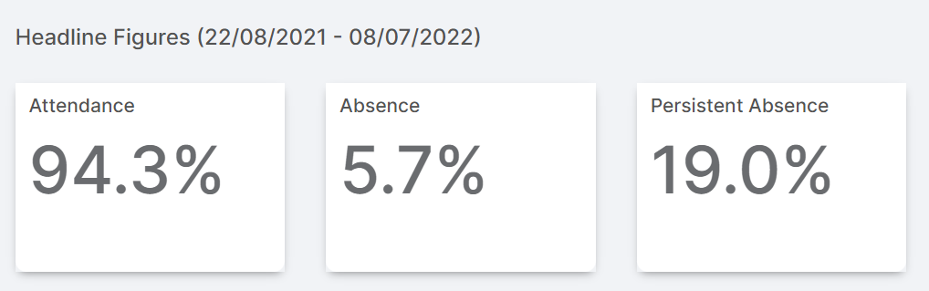
PP attendance in July 2022 was 92% whilst whole school attendance was 94.3%. This was impacted by the DSP children and exclusion data.
Close working relationships with the EWO ensured that poor attendance was challenged appropriately through letters, panel meetings and fines.
Bespoke plans were in place for families, who for many reasons (such as mental illness), were not able to get their children to school. This supported individual children.
Magic breakfast and nurture breakfast supported specific children with attendance and acted as incentive to be in school on time.
Minibus collections were implemented for two families who were struggling with morning routines and consequently, these children were in school and on time each day that this was in place.
- Exposure to increased mental illness
The work of the RB2L team (Behaviour mentor, Family Support Worker and Inclusion Base lead) supported children who had witnessed or who are exposed to mental illness in the home. Many children attended intervention sessions based upon building confidence and self esteem. 1:1 opportunities to talk with a trusted adult also supported vulnerable children in feeling safe and content in school and therefore able to access the school day.
Learnful- mindfulness techniques have supported children in managing their emotions when feeling overwhelmed.
Mental Health and wellbeing practitioner also supported many key children.

- Less experiences and enrichment as a result of covid
Music sessions on a 1:1 and small group basis were offered to targeted PP children free of charge (including Taiko drumming for LAC children).
Children began to access the enrichment offer sequenced across year groups in the attempt to enhance learning and lived experiences. This included the out door pursuits centre, the Year 6 residential, London theatre trip and pantomime to name just a few.
Dance teacher and sports coach provided children with high quality sports coaching. Commitment to learning in these sessions were incredibly high and resulted in an end of year production in Year 6. Many vulnerable/PP children accessed additional PE sessions with a focus on supporting social and emotional and mental health; this had a positive impact on children’s readiness to learn.

- The impact of covid on our disadvantaged
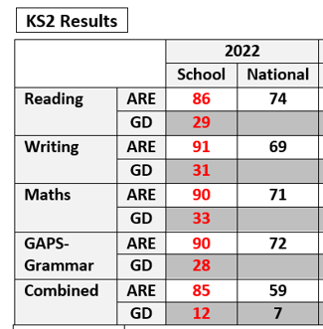
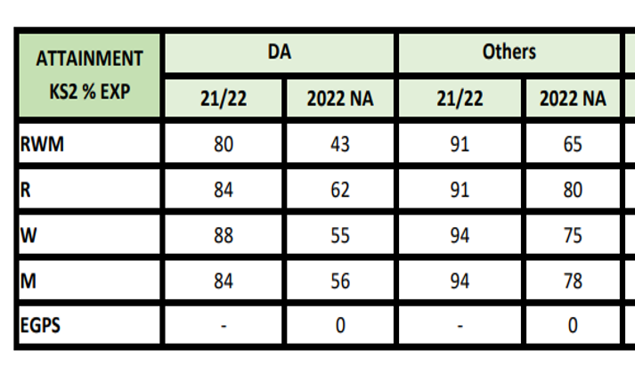
End of Key Stage 2 data demonstrated the accelerated progress that children had made. All data, including for disadvantaged children, was significantly above national expectations at the expected standard. Greater depth percentages were also significantly greater than the national picture. The attainment of disadvantaged children in comparison to national disadvantage was also significantly greater.

Externally provided programmes
Please include the names of any non-DfE programmes that you purchased in the previous academic year. This will help the Department for Education identify which ones are popular in England
Programme | Provider
N/A
N/A

Service pupil premium funding (optional)
For schools that receive this funding, you may wish to provide the following information:
Measure | Details
How did you spend your service pupil premium allocation last academic year? | N/A
What was the impact of that spending on service pupil premium eligible pupils?

Further information (optional)
Money not spent from 20/21 pupil premium has been carried over to support the 21/22 pupil premium strategy.

